|  |  |
| --- | --- |
|  | Paperpal Manuscript Processing Report  Date: Jan 1, 2022 |
| Language quality, mechanics and style | Mechanics and style covers issues like capitalization, hyphenation, punctuation, spacing etc. We have identified all 155 issues in this category. |
| Language quality, readability suggestions | Readability suggestions covers issues like conciseness, redundancy, transition and flow, and suggests improved phrasing. We have identified 117 issues in this category. |
| Language quality, vocabulary | Vocabulary covers issues like fluency, formality, and word choice. We have identified 46 issues in this category. |
| Language quality, writing errors | Writing errors covers issues like article usage, conjunctions, determiner errors, grammar, preposition usage, spelling, and unclear phrasing. We have identified 342 issues in this category. |

Date of publication xxxx 00, 0000, date of current version xxxx 00, 0000

*Digital Object Identifier 10.1109/ACCESS.2020.DOI*

**Efficient 3-D Near-Field MIMO-SAR**

**Imaging for Irregular Scanning**

**Geometries**

**JOSIAH W. SMITH1 AND MURAT TORLAK1**

1Electrical and Computer Engineering, The University of Texas at Dallas, 800 W. Campbell Rd. Richardson, TX 75080 USA (e-mail: jws160130@utdallas.edu) Corresponding author: Josiah W. Smith (e-mail: josiah.smith@utdallas.edu).

This work was supported by the Semiconductor Research Corporation (SRC) task 2712.029 through The University of Texas at Dallas’ Texas Analog Center of Excellence (TxACE).

 **ABSTRACT** In this article, we introduce a novel algorithm for efficient near-field synthetic aperture radar (SAR) imaging of irregular scanning geometries. With the emergence of fifth-generation (5G) millimeter-wave (mmWave) devices, near-field SAR imaging is no longer confined to laboratory environments. Recent advances in positioning technology have attracted significant interest for a diverse set of new applications in mmWave imaging. However, many use cases, such as automotive-mounted SAR imaging, unmanned aerial vehicle (UAV) imaging, and freehand imaging with smartphones, are constrained to irregular scanning geometries. Whereas traditional near-field SAR imaging systems and quick personnel security (QPS) scanners employ highly precise motion controllers to create ideal synthetic arrays, emerging applications, mentioned previously, inherently cannot achieve such ideal positioning. In addition, many Internet of Things (IoT) and 5G applications impose strict size and computational complexity limitations that must be considered for edge mmWave imaging technology. In this study, we propose a novel algorithm to leverage the advantages of non-cooperative SAR scanning patterns, small form-factor multiple-input multiple-output (MIMO) radars, and efficient monostatic planar image reconstruction algorithms. We propose a framework to mathematically decompose arbitrary and irregular sampling geometries and a joint solution to mitigate multistatic array imaging artifacts. The proposed algorithm was validated through simulations and an empirical study of arbitrary scanning scenarios. Our algorithm achieves high-resolution and high-efficiency near-field MIMO-SAR imaging, and is an elegant solution to computationally constrained irregularly sampled imaging problems.

 **INDEX TERMS** 5G, automotive SAR, drone mmWave imaging, freehand imaging, handheld scanner, irregular sampling, mmWave imaging, multistatic imaging, real-time imaging, synthetic aperture radar

(SAR)

|  |  |
| --- | --- |
| **I. INTRODUCTION**  Low-cost electromagnetic imaging systems have gained attention over the past decade as commercially available radar platforms have become increasingly affordable. Millimeterwave (mmWave) radar has attracted exceptional interest for applications including gesture recognition [1], concealed threat detection [2], [3], and medical imaging [4], [5] due to its semi-penetrating non-ionizing nature and low power consumption. Additionally, with the emergence of fifth-generation (5G) and sixth-generation (6G) technology, ultra-wideband (UWB) mmWave transceivers are enabling unprecedented sensing and communications feats [6]–[8]. | Small form-factor multiple-input-multiple-output (MIMO) radars are increasing in popularity due to low cost and power consumption [3], [9]. In addition to emerging 5G communications, mmWave radar has already been realized for high-resolution sensing on the Google Pixel 4 [8]. Of particular interest, recent work has enabled freehand mmWave imaging by employing positioning sensors commonly employed in smartphones and virtual reality (VR) sensor suites [7], [10]–[13]. Sub-wavelength localization accuracy was previously unachievable by conventional techniques such as 5G mmWave [14] or Bluetooth low energy (BLE) ranging [15]. Freehand mmWave imaging is a high-resolution imaging |
| VOLUME 4, 2016 | 1 |

technique that relies on conventional synthetic aperture radar (SAR) principles [16]–[20] and precise tracking of the handheld radar device as it is moved by a human user throughout space [7], [21]–[23]. Whereas traditional mmWave SAR imaging requires precise motion systems to achieve near-ideal synthetic arrays [20], the scanning geometry employed by freehand imaging systems is generally irregular and does not conform to the typical array geometries required for efficient image reconstruction algorithms [24].

While recent work has proposed a fast imaging algorithm for irregular SAR geometries using array linearization [25], the proposed technique adopts a simplistic model of the array displacement and does not explore near-field multistatic effects, both of which are addressed in this study. However, efficient algorithms for near-field MIMO-SAR operations under irregular scanning geometries have not been explored in the literature.

Extensive work on freehand mmWave imaging was conducted by Laviada *et al.* at the University of Oviedo [7], [10]–[13], [26], [27]. High-precision localization systems that enable freehand SAR imaging have been investigated using an infrared camera network to accurately track the device location across time and recover electromagnetic (EM) images [10]. Their work was extended to employ an inertial measurement unit (IMU) and depth camera sensors to achieve standalone freehand imaging with promising results [7], [13]. In each of these efforts, the subject attempted to move the hand in a raster pattern to synthesize an approximately rectangular planar aperture with a linear frequency-modulated (LFM) handheld radar [7], [10], [11]. Owing to the subject’s inability to move their hand in an ideal planar trajectory and the sensitivity of the mmWave signal to submillimeter perturbations, the image was reconstructed using the generalized back-projection algorithm (BPA).

Similar irregular and noncooperative scanning geometries have been observed in unmanned aerial vehicle (UAV) SAR imaging [26], nonuniform NDT [27], and automotive SAR imaging [28]. However, for many edge and mobile applications, limitations on power consumption and computational complexity cannot be overcome using existing approaches for irregularly sampled SAR. Although image reconstruction algorithms have been thoroughly investigated in the literature for cooperative synthetic array geometries [1], [3], [9], [16]– [20], [24], [29]–[33], widely applicable efficient near-field imaging algorithms for applications such as freehand smartphone imaging, UAV imaging, and automotive SAR imaging have not been thoroughly addressed in the existing literature. Furthermore, while MIMO arrays, commonly employed in commercially available radar devices, offer spatially efficient small array sizes, the MIMO-SAR operation introduces a handful of complications to the image reconstruction process, and proper handling of the multistatic array is necessary to avoid imaging artifacts [17]. While progress has been made towards projecting MIMO-SAR radar data to virtual single-input-single-output (SISO) monostatic data [17], [24], the analysis is performed on a coplanar assumption that does not generally hold for irregular scanning geometries.

In this study, we propose a novel image reconstruction technique for efficient near-field imaging with irregular scanning geometries, such as those present in freehand imaging, UAV SAR, or automotive scenarios. We examined the system and signal models for UWB MIMO-SAR and developed a multiplanar multistatic approach to mathematically decompose the irregularly sampled synthetic array such that an equivalent virtual planar monostatic array can be constructed. This technique is the first to extend the range migration algorithm (RMA) such that noncooperative SAR scanning and multistatic effects are simultaneously mitigated. The analysis in the subsequent sections provides a novel framework for decomposing irregular SAR scenarios and efficiently projecting irregular MIMO-SAR samples into a virtual planar monostatic equivalent. The proposed algorithm was validated through simulation and experimentation, demonstrating its robustness to arbitrary scanning patterns and low computational complexity. A thorough study of the relationship between the array irregularity and image resolution of the proposed algorithm. The proposed technique demonstrates high-fidelity focusing comparable to the traditional planar RMA, even under array perturbation on the order of 10s of wavelengths. Our solution enables the development of emerging technologies that require non-ideal SAR scanning geometries, MIMO multistatic radar, and efficient image reconstruction.

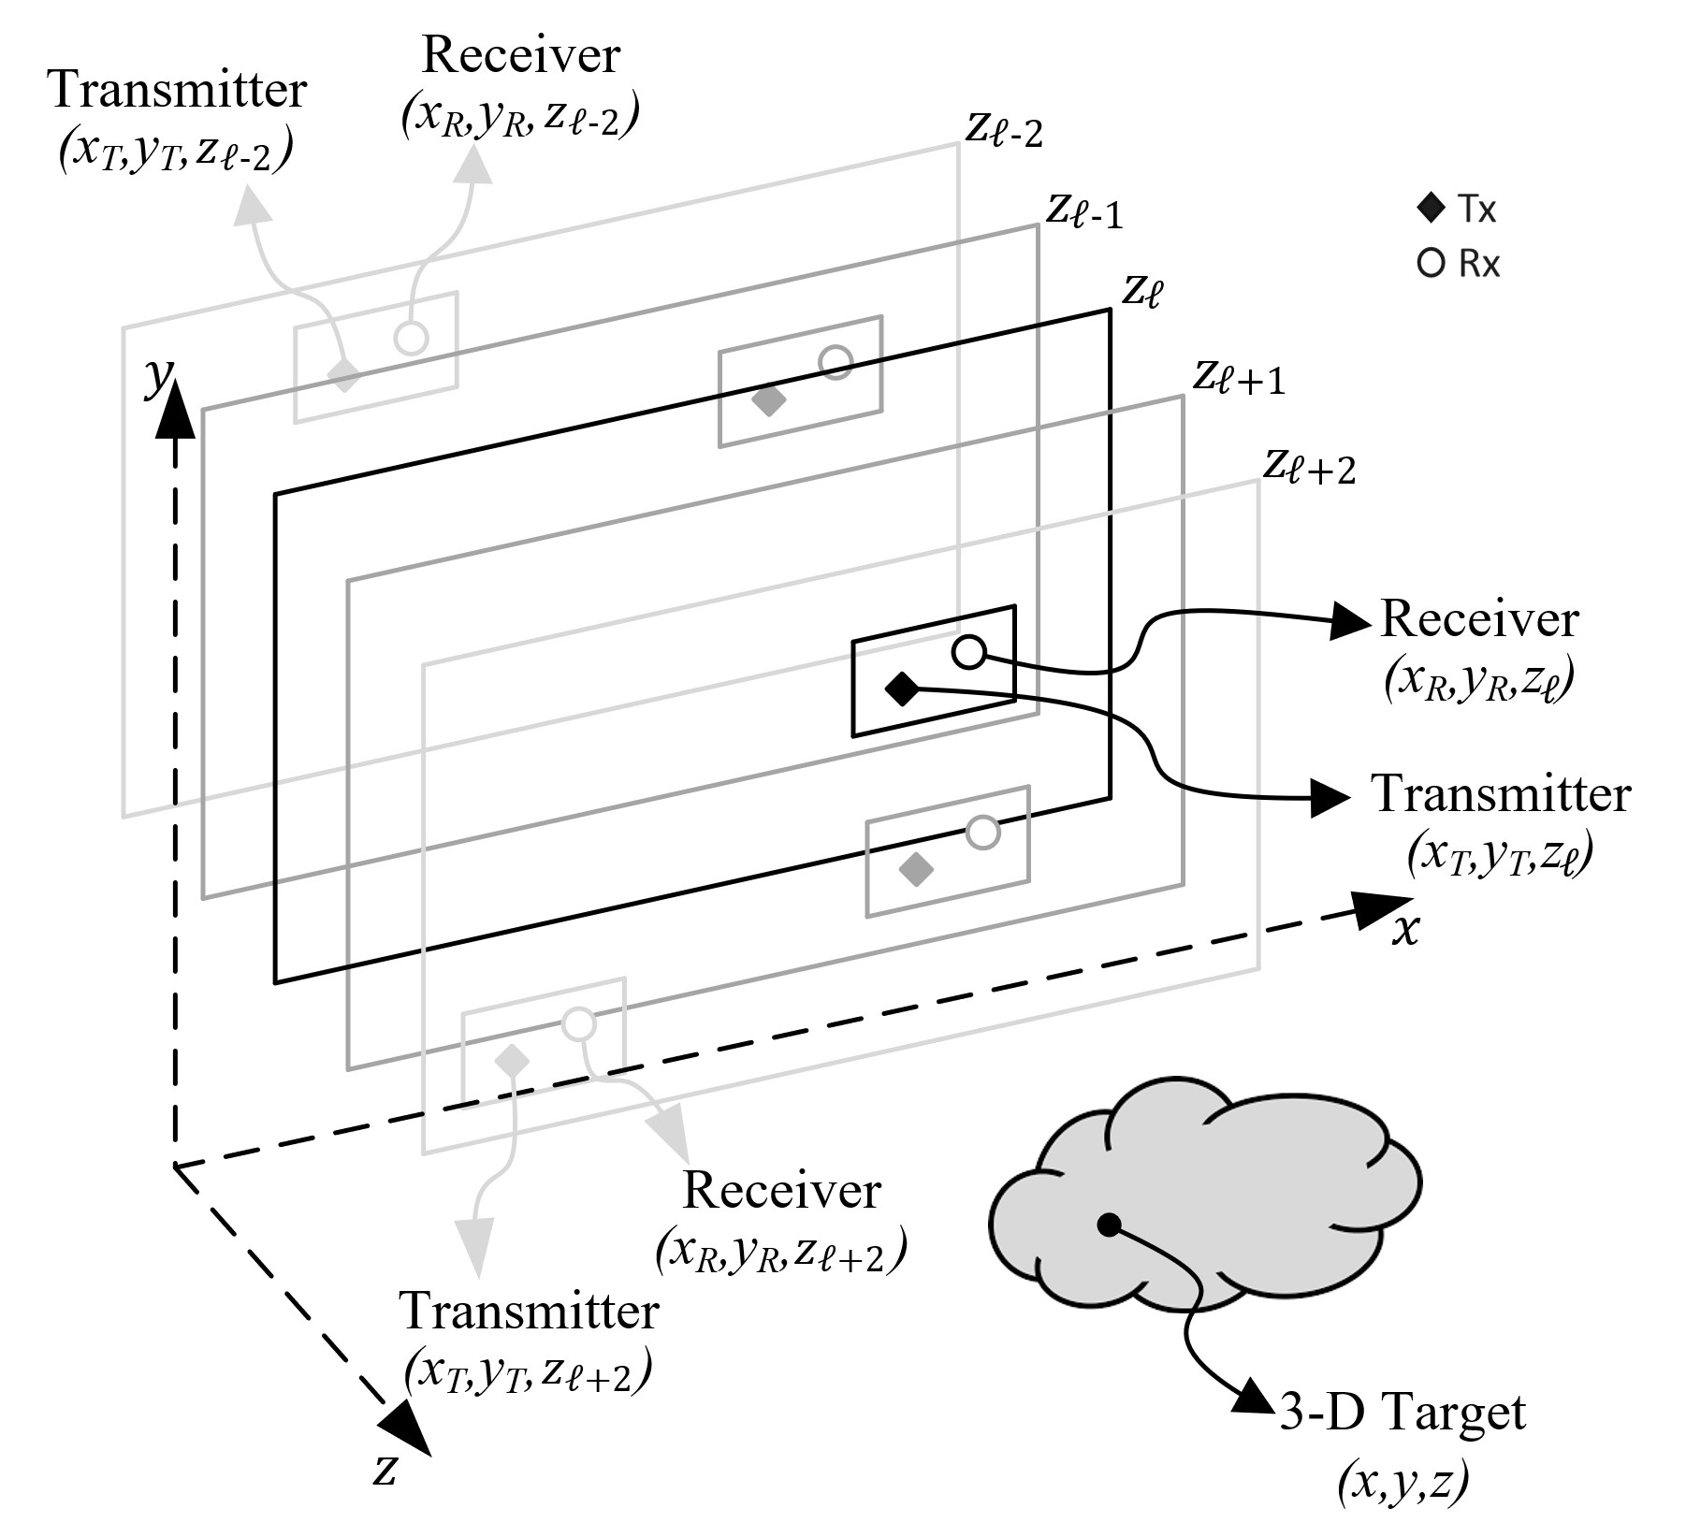

Figure 1: Geometry of the multi-planar SAR irregular scanning geometry with a multistatic array.

The remainder of this paper is organized as follows. Section II introduces the system model, including the multiplanar multistatic SAR concept, the signal model, and a novel compensation technique for planar monostatic SAR. In Section III, efficient imaging methods and implementation details are discussed and an enhanced algorithm is proposed. Section IV details the hardware and software implementation for collecting multiplanar multistatic SAR data. The results of the simulation and empirical studies are presented and discussed in Section V, followed by the conclusions.

# II. SYSTEM MODEL

In this study, we propose the characterization of irregular or arbitrary three-dimensional (3-D) MIMO-SAR sampling geometry using the multi-planar multistatic scenario shown in Fig. 1, where data are collected along different *z*-planes by a MIMO multistatic radar with respect to a stationary 3-D target.

# A. MULTI-PLANAR MIMO-SAR CONFIGURATION

For many SAR applications mentioned in Section I, as the radar is moved throughout 3-D space, it is generally oriented in the same direction towards some target; however, the samples are taken across several *z*-planes. As the data are collected during an arbitrary SAR scanning path, the resulting synthetic aperture does not conform to standard scanning regimes, such as rectilinear/planar [2], [20], circular [27], [32], or cylindrical [16], [24], [33]. Hence, the image reconstruction process must consider the irregularity of spatial sampling, the geometry of which is detailed in Fig. 1.

Compared with planar MIMO-SAR, which requires a multistatic MIMO array to be scanned across a planar track [17], [20], [31], multi-planar MIMO-SAR allows the multistatic array to be scanned across a 3-D space. For freehand imaging or automotive SAR, a MIMO array is fixed to a smartphone or vehicle, respectively, and is moved throughout space, generating a multi-planar MIMO-SAR irregular aperture. As shown in Fig. 1, because the multistatic array is scanned in an irregular pattern spanning multiple *z*-planes, the locations of the transmit (Tx) and receive (Rx) elements are spatially translated by the movement of the MIMO array. The analyses in the subsequent sections present an efficient solution to irregular MIMO-SAR imaging, such that the position of the radar is known throughout the scan and the planar array assumption does not hold. This scenario is common for many of the aforementioned applications and necessitates both irregular scanning geometries and efficient image recovery.

# B. THE 3-D MULTI-PLANAR VIRTUAL ARRAY RESPONSE IN NEAR-FIELD IMAGING

By the analysis of [17], [24], [34] for the 2-D case, a multistatic MIMO array can be approximated by a monostatic virtual element located at the midpoint of the Tx and Rx elements under the far-field assumption for a small fraction *ϵ* as

q(*d y* 2 ≤ √4*ϵλR,* (1)

*x*)2 + (*dℓ*) *ℓ*

where *dxℓ* , *dyℓ* are the distances between the Tx and Rx elements along the *x*- and *y*-directions, respectively, as shown in Fig. 2, *λ* is the wavelength of the carrier frequency, and *R* is the distance from the midpoint of the antenna elements to a reference point in the scene.

However, under the multiplanar multistatic framework, it is desirable to approximate each Tx/Rx pair using its virtual element located on a *Z*0 plane in the near field. Thus, multiplanar data can be projected onto a virtual planar array to ease the subsequent image reconstruction process. As shown in Fig. 2, the *ℓ*-th Tx/Rx pair located on the *zℓ* plane can be approximated by the element located at the midpoint between the Tx and Rx elements migrating to the *Z*0 plane.

For near-field SAR, the assumption in (1) is invalid, and the approximation must be handled more delicately. Hence, we derived an efficient compensation algorithm to approximate the multistatic multiplanar array as a monostatic planar array for near-field imaging scenarios.

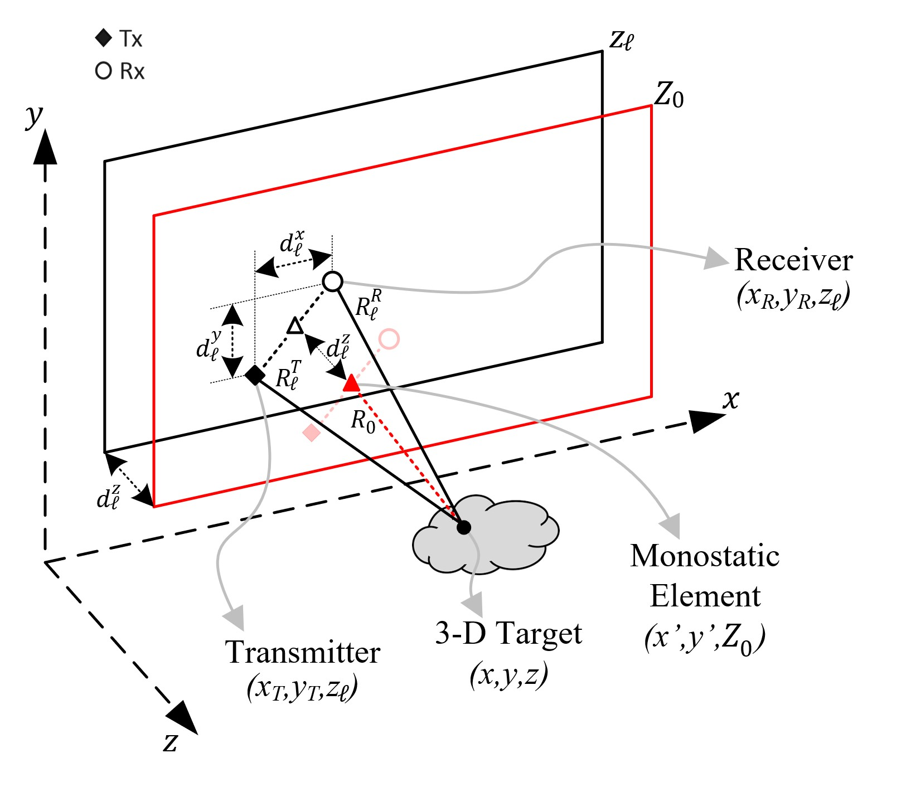

Figure 2: Relationship between the multi-planar multistatic elements and virtual planar monostatic elements.

The transmitter (Tx) and receiver (Rx) of the *ℓ*-th multistatic MIMO array are located at (*xT,yT,zℓ*) and (*xR,yR,zℓ*), respectively, and the target scene is assumed to be a distributed target whose coordinates are given by (*x,y,z*). In this study, orthogonality is leveraged across time by operating a MIMO radar using the time-division multiplexing (TDM) MIMO technique such that each Tx/Rx pair is activated sequentially. The round-trip distance between the *ℓ*-th Tx/Rx pair and the point scatter located at (*x,y,z*) can be written as

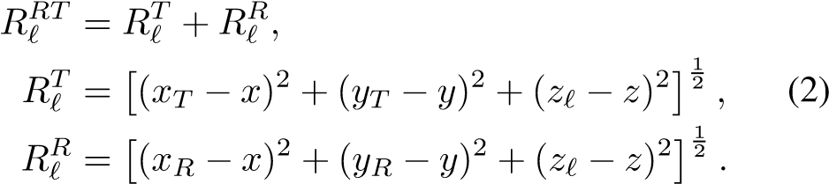

Denoting the virtual antenna element locations as (*x*′*,y*′*,Z*0), the *x*- and *y*-coordinates of the Tx/Rx pair can be expressed as:

|  |  |  |
| --- | --- | --- |
| *xT* = *x*′ − *dxℓ /*2*, xR* = *x*′ + *dxℓ /*2*,* | *yT* = *y*′ − *dyℓ/*2*, yR* = *y*′ + *dyℓ/*2*.* | (3) |

Similarly, denoting *dzℓ* as the distance between the *Z*0 plane and the *zℓ* plane, as shown in Fig. 2, the *z*-coordinate of the Tx and Rx elements can be expressed with respect to

*Z*0 as

*zℓ* = *Z*0 + *dzℓ.* (4)

As described in Appendix A, substituting (3) and (4) into (2) and applying the third-order Taylor series expansion of *Rℓ* for small values ofand yields

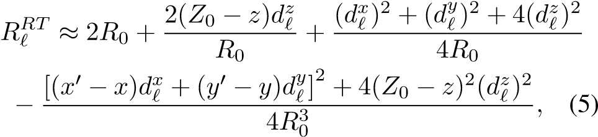

where *R*0 is the distance between the virtual monostatic element located at (*x*′*,y*′*,Z*0) and the point scatterer at (*x,y,z*), expressed as:

 *.* (6)

Centering the target to the origin of the (*x,y,z*) coordinate system and considering (*x*′ − *x*)*,*(*y*′ − *y*) ≪ *Z*0, we can acquire the improved approximation of the round-trip distance between the *ℓ*-th Tx/Rx pair and the point scatterer as

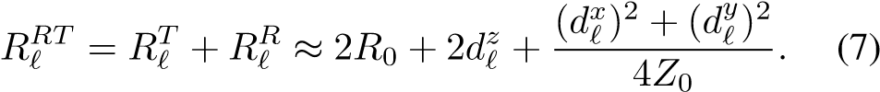

## *C. SIGNAL MODEL*

Consider the multi-planar multistatic array whose Tx and

Rx elements are located at (*xT,yT,zℓ*) and (*xR,yR,zℓ*), respectively, and a distributed target occupying volume *V* at locations (*x,y,z*) in 3-D space with a continuous reflectivity function given by *o*(*x,y,z*). Without loss of generality, under the Born approximation for the scattering process and an isotropic antenna assumption, the received signal can be written as:

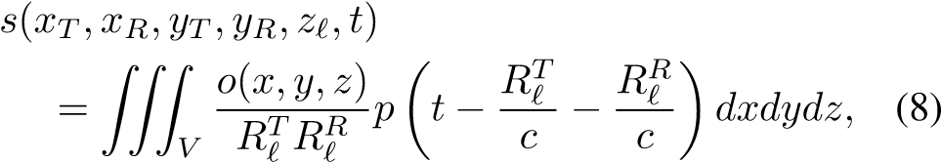

where *p*(*t*) is the transmitted signal, *t* is the fast-time variable, *c* is the speed of the EM wave, and *RℓT*, *RℓR* are given in (2).

The Fourier transform of (8) with respect to *t* yields the frequency spectrum as

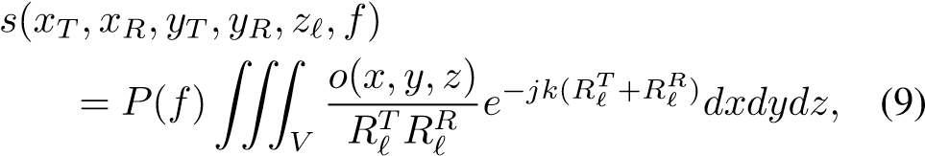

where *k* = 2*πf/c* is the instantaneous wavenumber and *P*(*f*) is the Fourier transform of *p*(*t*). Image recovery requires the inversion of (9) to produce *o*(*x,y,z*); however, given arbitrary sampling locations, the image cannot be computed efficiently using existing techniques [7], [10]–[13], [26], [27]. The frequency-domain model of the received signal (9) is valid for any UWB radar signaling scheme, including frequency-modulated continuous-wave (FMCW), phase-modulated continuous wave (PMCW), and orthogonal frequency-division multiplexing (OFDM), which are commonly employed in 5G and IoT applications [35]. Furthermore, prior research on freehand imaging and similar IoT applications has employed a purely stepped-frequency FMCW signal model [10]–[13]. Similarly, Google Pixel 4 utilizes a Google Soli 60 GHz mmWave FMCW radar for sensing [8].

However, the derivation of (7) enables efficient compensation of multistatic multiplanar data by careful handling of the phase. To achieve the proposed compensation, we express the frequency response of the virtual planar monostatic array, whose elements are located at (*x*′*,y*′*,Z*0), as

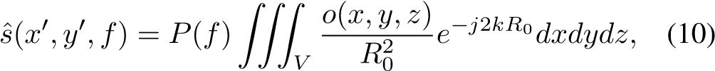

where *R*0 is given by (6), *x*′ and *y*′ are the midpoints between each Tx/Rx pair, and *Z*0 is the plane on which the samples are projected. From the analysis in Section II-B, the relationship between the multiplanar multistatic response and the virtual monostatic array response is given by *s*ˆ(*x*′*,y*′*,f*) ≈ *s*(*xT,xR,yT,yR,zℓ,f*)*ejkβℓ,* (11)

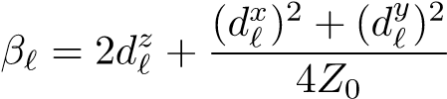where

*,* (12)

is the near-field residual phase term owing to the arbitrary scanning and MIMO effects in the near-field, as derived in (7). Hence, the virtual planar monostatic response can be efficiently acquired from irregular samples by removing the residual phase to simultaneously account for the multi-planar scanning geometry and near-field multistatic effects. The novel phase compensation technique derived in this section efficiently reduces the dimensionality of the MIMO-SAR imaging problem and projects multiplanar samples onto a single plane to enable computationally tractable algorithms for image reconstruction.

## III. EFFICIENT IMAGE RECONSTRUCTION

### ALGORITHMS FOR NEAR-FIELD SAR

In this section, we review traditional planar SAR image reconstruction methods using efficient Fourier-based solutions to recover EM images [24] and propose a novel technique for multiplanar multistatic SAR. Existing research on irregularly sampled SAR imaging problems employs the gold-standard back-projection algorithm (BPA) [7], [10]–[13], [26], [27]. However, this approach is computationally infeasible for several edge and mobile applications. To overcome this challenge, we employ the approximation in (11) to project multiplanar data to a planar-sampled scenario to satisfy the requirements for efficient image reconstruction. The Fourierbased algorithm detailed in the subsequent analysis is known as the range migration algorithm (RMA) or *f*-*k* algorithm, and has been explored in greater detail elsewhere [18], [24], [29]–[31].

The key step to efficiently invert the integral in (10) is to represent the spherical wave term as a superposition of plane waves using the method of stationary phase (MSP) [17], [24], such that

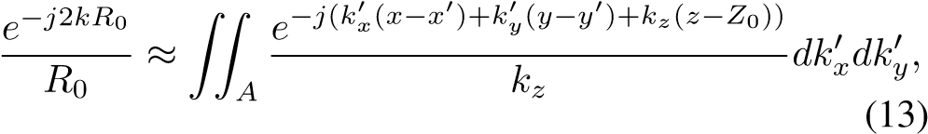

where

*,* (14)

and *A* is the region inspace occupied by the spherical wavefront.

Following the analysis in [20] and [24], substituting (13) into (10) and rearranging the phase terms to leverage the Fourier relationships yields

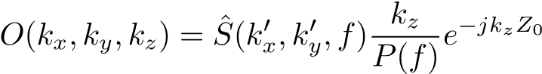*,* (15)

where *O*(*kx,ky,kz*) and are the spatial spectral representations of the reflectivity function *o*(·) and the array response *s*ˆ(·), respectively. Because the primed and unprimed coordinate systems are coincident, the distinction can be dropped for the remaining analysis. Hence, the RMA image-recovery process can be summarized as *o*(*x,y,z*) = IFT. 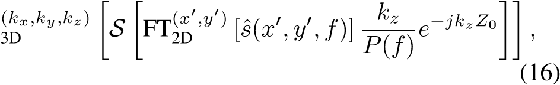

where FT[·] and IFT[·] are the forward and inverse Fourier transform operators, respectively; S is the Stolt interpolation operator required to compensate for the spherical wavefront [24]; and *s*ˆ(·) is obtained from (11). The spatial resolution along each dimension of the recovered image is given by:

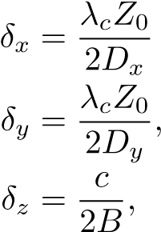*,*

(17)

where *Dx* and *Dy* are the sizes of the aperture along the *x*- and *y*-directions, respectively, *B* is the system bandwidth, and *λc* is the wavelength of the center frequency [17], [24], [30].

While (16) provides an efficient solution for planar array imaging problems, its application to irregular scanning geometries requires a discussion of several key issues. Applying the compensation technique in (11) for irregularly sampled data, the multi-planar data can be approximated by planar sampling; however, they are likely non-uniform at the positions (*x*′*,y*′*,Z*0) along the *x*- and *y*-directions. Traditional efficient implementations rely on the common fast Fourier transform (FFT) algorithm, but recent work on non-uniform planar MIMO-SAR [30], [31] and irregular MIMO real aperture radar (MIMO-RAR) [36] imaging has produced solutions using a non-uniform FFT (NUFFT) approach employing fast Gaussian gridding (FGG), as discussed in [37], for the Fourier transforms and Stolt interpolation step in (16). The sampling criteria for the non-uniform planar case are discussed in detail in [30], [31], [36] and applied correspondingly to irregular scanning scenarios after multiplanar compensation. Similarly, the FGG-NUFFT technique was employed in this study to perform RMA efficiently on irregularly sampled planar data.

For the multiplanar sampling scenario discussed in Section II-A, the RMA cannot be applied directly without multiplanar compensation because the data are sampled on different *z*-planes, as discussed in Section V. If the RMA is applied to the raw multi-planar data, the forward Fourier transform in (16) is invalid because the data along the *x*′ and *y*′-directions are not coplanar and the resulting image will suffer from significant distortion, rendering the resulting images unusable in most cases.

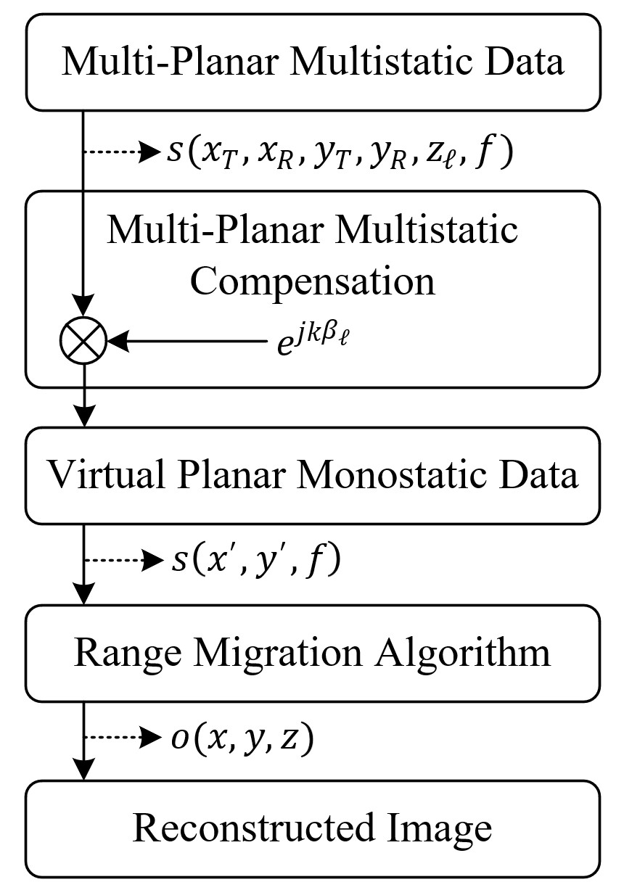

Figure 3: The complete image reconstruction process from irregular sampling compensation to RMA image recovery.

|  |
| --- |
| Figure 4: System design for 3-D scanner with radar mounted on planar *x*-*y* rails and target mounted on a linear *z* rail. The TI radar, data capture card, and mechanical scanner are controlled by MATLAB via USB serial interface. |

Sampling considerations for image reconstruction remained identical to those in analyses elsewhere [17], [29], after the multi-planar compensation algorithm. The baseband frequency sampling criteria can be determined using the maximum range for a given application. As given in [38], the maximum frequency sampling interval is given by ∆*f < c/*(2*R*max), where *R*max is the maximum target range. Although spatial sampling criteria are not guaranteed for irregular SAR scanning if the relationship between the capture rate of the radar and the velocity of the radar platform is tuned appropriately during system design, undersampling artifacts are minimal in most cases [10]–[13]. To avoid spatial undersampling, the lower bound of the pulse repetition frequency (PRF) can be computed using PRF *>* 4*v*max*/λc*, where *v*max is the maximum velocity for a certain application. For example, assuming that the maximum velocity of the human hand for a freehand SAR is 1 m/s and a center frequency of 79 GHz, the lower bound of the PRF is approximately 1.06 kHz. It is important to note that the number of captures increases proportionally to the PRF; hence, at high velocities, a large number of samples are captured. The computational performance of traditional techniques that employ BPA degrades substantially when many samples are captured. On the other hand, the signal-to-noise ratio can be improved by increasing the number of samples at the cost of an increased computational burden. Hence, an efficient algorithm for multiplanar MIMO-SAR imaging is required to enable many such technologies.

In terms of computational complexity, our proposed algorithm offers a significant advantage over existing techniques in the literature [7], [10]–[13], [26], [27], which employ BPA, whose computational complexity is on the order of *O*(*N*6) [20], [31]. The time complexity of the RMA and its FGG-NUFFT variants are investigated in the literature [31], [36] and the multi-planar compensation step proposed in this article presents negligible computational expense to the RMA, which is on the order of *O*(*N*3 log*N*) [19], [29]. Hence, as discussed in Section V, the algorithm proposed in this article offers comparable imaging performance to BPA with tractable execution time for mobile platforms, similar to RMA.

A novel enhanced reconstruction process for efficient near-field SAR imaging with irregular scanning geometries is shown in Fig. 3. Using the analysis in Section II, irregular scanning geometries can be modeled as multiplanar sampling scenarios, as shown in Fig. 1, and compensated by removing the residual phase owing to the multiplanar multistatic conditions. The key difference between traditional RMA and the proposed algorithm is the alignment of the multi-planar multistatic (MIMO-SAR) data to virtual planar monostatic data. This crucial step compensates for both the sampling irregularities and multistatic MIMO effects simultaneously, while significantly reducing the dimensionality, from 6-D (*xT,xR,yT,yR,zℓ,f*) to 3-D (*x*′*,y*′*,f*), and subsequently the computational complexity. Subsequently, virtual planar monostatic data were used to efficiently recover the image using RMA. In simulation and empirical studies on irregular SAR scanning geometries, the proposed algorithm is applied to efficiently produce high-resolution 3-D images previously infeasible owing to algorithmic deficiencies.

## IV. MULTI-PLANAR MULTISTATIC IMAGING HARDWARE

### PROTOTYPE

In this section, we discuss the hardware prototype implementation for empirically validating the proposed imaging algorithm by collecting multiplanar multistatic SAR data. The hardware architecture of the mmWave imaging system is illustrated in Fig. 4. Texas Instruments (TI) mmWave MIMO radar was mounted on an *x*-*y* planar scanner. The TI AWR1443BOOST radar with a 4 GHz bandwidth from 77 GHz to 81 GHz is mounted on a TI mmWave-Devpack and TSW1400 data capture card to store the data from the SAR scan and transfer it to the PC, where the image recovery algorithm is implemented in MATLAB. TI AWR1443BOOST is equipped with a MIMO array consisting of two Tx elements spaced by 2*λc* and four Rx elements spaced by *λc/*2 [17]. Although 5G and IoT applications commonly employ an OFDM modulation scheme, the TI radar employed for the following experiments is limited to FMCW signaling. In contrast, FMCW radar has been utilized for smartphone applications, notably Google Pixel 4, which is equipped with Google Soli FMCW radar [8]. The proposed range migration-based algorithm is applicable to both OFDM and FMCW radars; hence, the results discussed in the following section are relevant for a wide array of 5G, IoT, smartphone, and automotive applications [39].

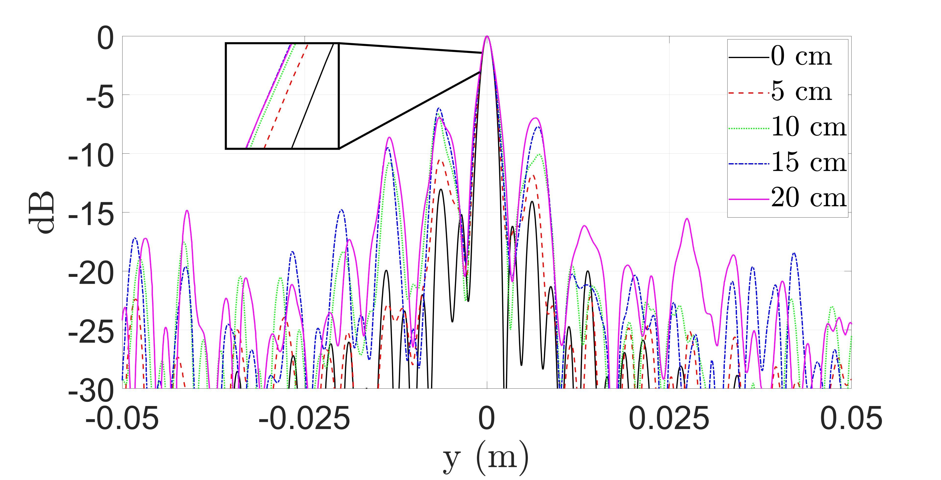

(a)

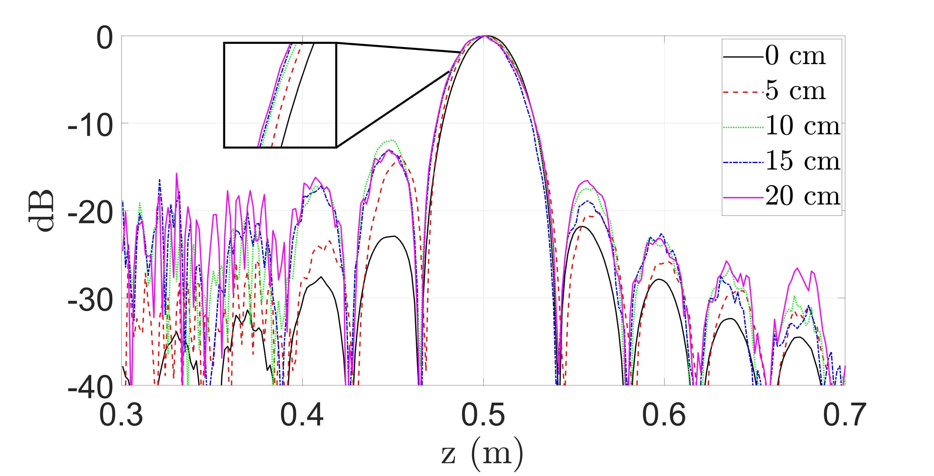

(b)

Figure 5: Comparison of point spread function (PSF) resolution along the (a) *y*- and (b) *z*-direction with varying maximum distance from the reference plane, *Z*0, to the samples at *zℓ*. The distance between the samples and reference plane, ∆max*z* , is varied from 0 cm (linear) to 20 cm with a step size of 5 cm. The linear case (0 cm) is computed with the conventional RMA. Each of the remaining PSFs are computed using our proposed algorithm.

Additionally, a linear rail was used to move the target along the *z*-direction to collect multi-planar multistatic data under the geometry discussed in Section II-A. All three *x*-*y*-*z* rails were driven by stepper motors controlled by an AMC4030 motion controller, and the scanning process and radar setup were handled in MATLAB. Additional details on system development and device calibration can be found in [20]. The images were reconstructed using MATLAB implementations running on a desktop PC equipped with a 12-core AMD Ryzen 9 3900X running at 4.6 GHz with 64 GB memory. Using this hardware prototype, data can be collected for many target scenarios under the multiplanar multistatic scenario by performing multiple planar SAR scans with the target at different *z*-locations. To emulate irregular scanning geometries, the data collected throughout *the x*-*y*-*z* space are subsampled, as discussed in Section V. Implementation in the literature employs multicamera infrared camera systems to track the radar as it is moved through space by the user [10], [11]. Other studies on irregular scanning geometries have explored freehand imaging using a stereo camera with an IMU for positioning estimation [7] and UAV near-field imaging with a laser rangefinder and a real-time kinematic (RTK) system for localization [26]. These implementations, among others [12], [13], [27], [28], demonstrate the viability of high-resolution sensors for precise positioning to enable novel imaging techniques using UWB mmWave radars. Hence, this study focuses on improving the computational efficiency of the imaging technique and assumes that the radar position is known across an irregularly sampled geometry.

## V. MEASUREMENT AND IMAGING RESULTS

In this section, we validate the proposed algorithm derived in Sections II and III, as illustrated in Fig. 3. Irregular scanning geometries were simulated using the simulation platform developed in [24], and image reconstruction results are shown by comparing our enhanced method to the gold standard BPA and RMA without multi-planar multistatic compensation. Similarly, using the 3-D mechanical system detailed in Fig. 4, irregular scanning geometries were emulated by collecting planar scans with the target at different *z*-locations and subsampling the collected data. Imaging results were obtained by comparing the proposed algorithm with BPA and RMA, demonstrating the computational advantage of our technique. The proposed multiplanar multistatic compensation algorithm achieves image quality comparable to that of BPA while offering time and space complexity on par with RMA.

# A. SIMULATED SAR IMAGING RESULTS

To validate our proposed algorithm in a simulation, we considered three distinct scenarios. First, we investigated the impact of array irregularities on image resolution. We consider the point spread functions (PSFs) for several multi-planar MIMO-SAR scenarios and compare them with an ideal planar scanning scenario to analyze the range and cross-range resolution of the proposed algorithm. We assume a single, ideal point target located at (0*,*0*,*0*.*5 m) in 3-D space for the PSF simulation. For comparison, an ideal linear MIMO-SAR pattern was generated along with several irregular SAR scanning patterns with increasing irregularity. Each non-cooperative motion track was generated by a semi-smooth, random curve spanning *y*′ ∈ [−12*.*5*,*12*.*5] cm with varying *zℓ* around *Z*0 = 0 m with 256 sampling locations, as shown in Fig. 6a. To analyze the impact of *dzℓ* = *zℓ* − *Z*0, the distance between the reference

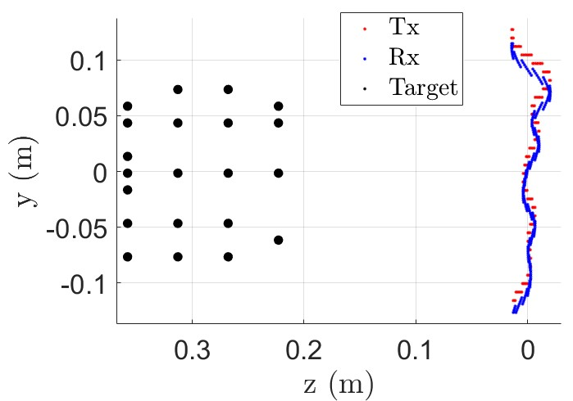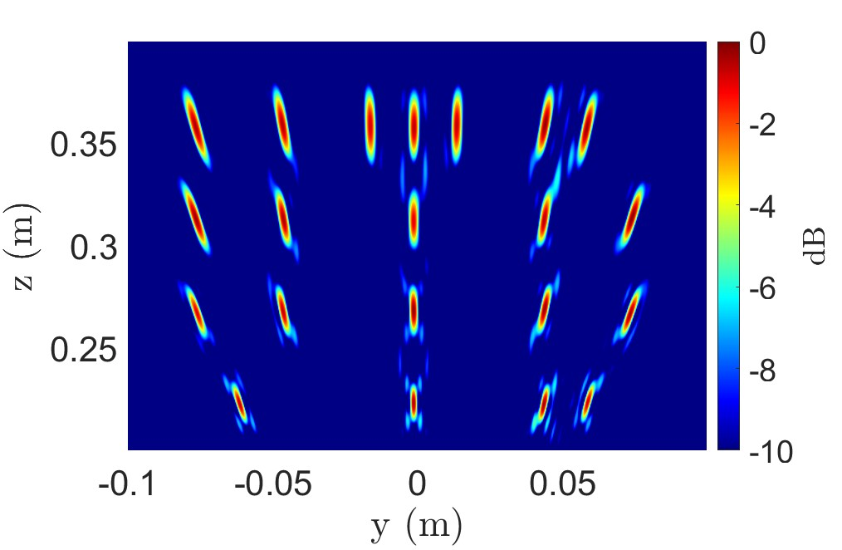

(a) (b)

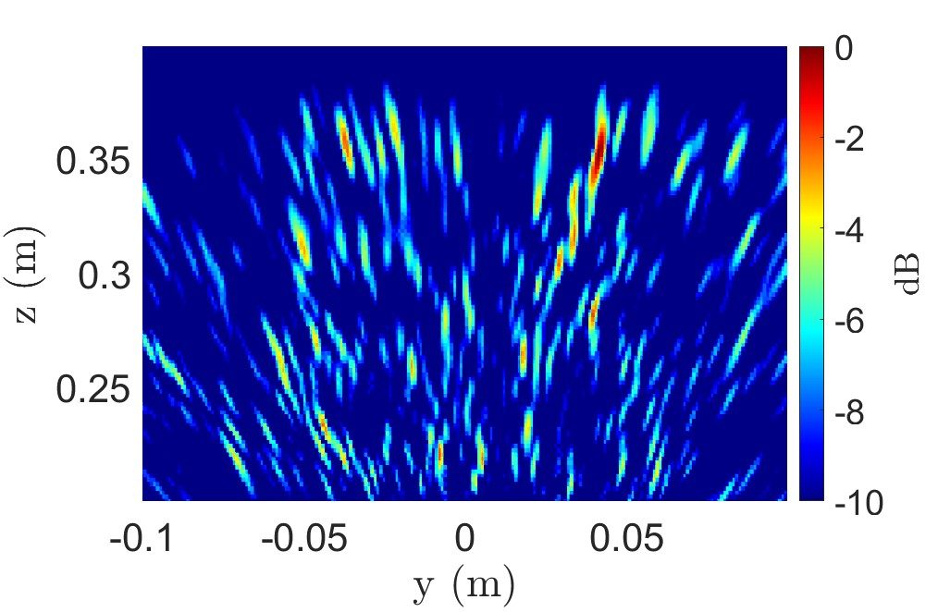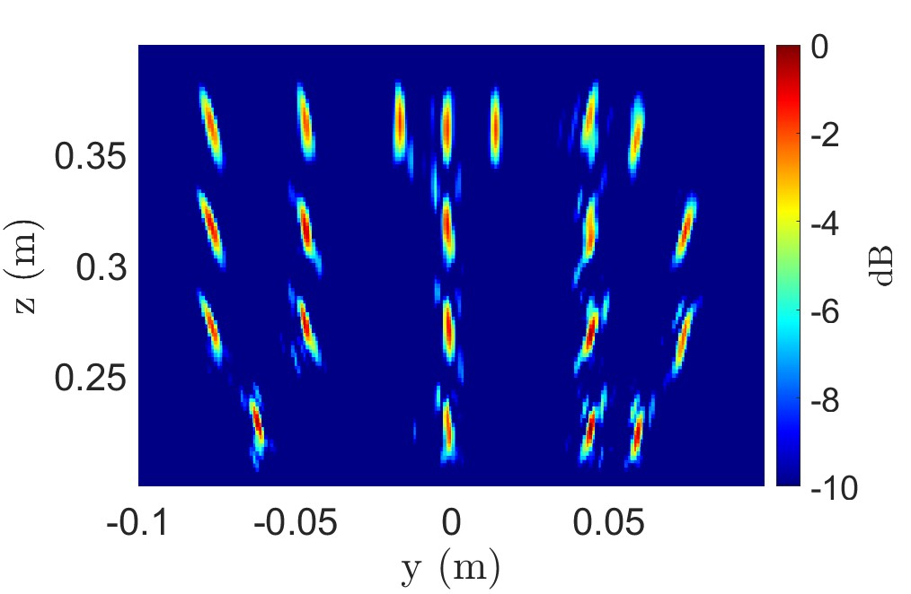

(c) (d)

Figure 6: (a) Irregular scanning geometry for “UTD” scenario consisting of a multi-linear array in the *y*-direction at *x* = 0 m and corresponding imaging results using the (b) BPA (296.3 s), (c) RMA without multi-planar multistatic compensation (29 ms), and (d) our proposed algorithm (30 ms).

plane at *Z*0 and the samples at *zℓ*, we simulate several multiplanar multistatic with increasing variance of *dzℓ*, as shown in Fig. 5. The absolute maximum distance, ∆max*z* ≜ max|*dzℓ*|, varies from 0 cm, the linear case, to 20 cm with a step size of 5 cm. At a center frequency of 79 GHz, ∆max*z* = 20 cm is more than 50 times the wavelength and *λc* = 3.79 mm. Prior work on freehand smartphone imaging system design assumes deviations of the order of 1 cm [7]. Along the cross-range dimension, which is symmetric along both the *x*- and *y*-directions, the resolution is minimally affected by the irregular scanning geometry when the algorithm is applied, as shown in Fig. 5a. However, a direct relationship between  and the main beamwidth is observed along with decreased sidelobe suppression compared to the ideal linear case, where traditional RMA can be employed directly. Along the *z-direction*, the resolution of the proposed algorithm suffers as  increases, but remains quite similar to the resolution of the linear case, as shown in Fig. 5b. Hence, our efficient algorithm achieves a focusing performance similar to that of the ideal linear or planar RMA case while allowing for irregular scanning geometries with large deviations from the reference plane in the *z*-direction.

To evaluate the performance of the algorithm for more complex targets, a linear array along the *y*-axis is simulated as shown in Fig. 6a with 21 point scatterers arranged as the letters “UTD.” Again, irregular array locations are generated by a semi-smooth, random curve spanning *y*′ ∈ [−12*.*5*,*12*.*5] cm and *zℓ* ∈ [−2*.*5*,*2*.*5] cm with 256 sampling locations. As shown in Fig. 6b, the gold standard BPA recovers each point scatterer without artifacts; however, computing the BPA image requires 296.3 s on our machine.

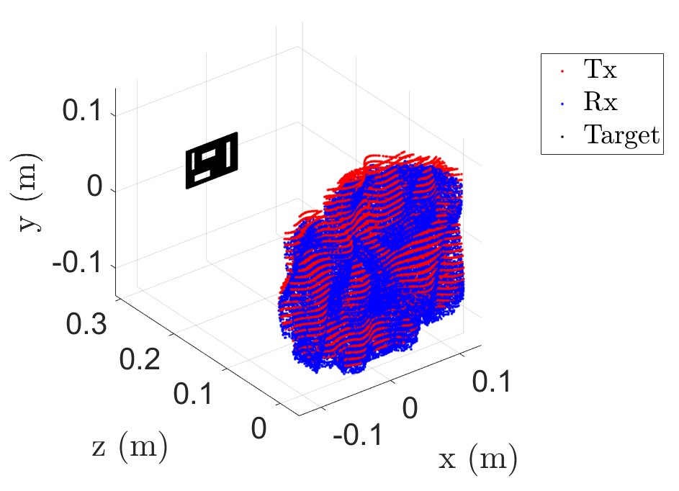

Figure 7: Irregular scanning geometry for cutout consisting of a multi-planar array along the *x*- and *y*-directions.

RMA without multiplanar multistatic compensation and the proposed algorithm are considerably more efficient, requiring only 30 ms for computation. However, while the RMA image in Fig. 6c is significantly distorted and the image is lost, our proposed method resolves the point targets comparably to BPA and requires a fraction of the computation time.

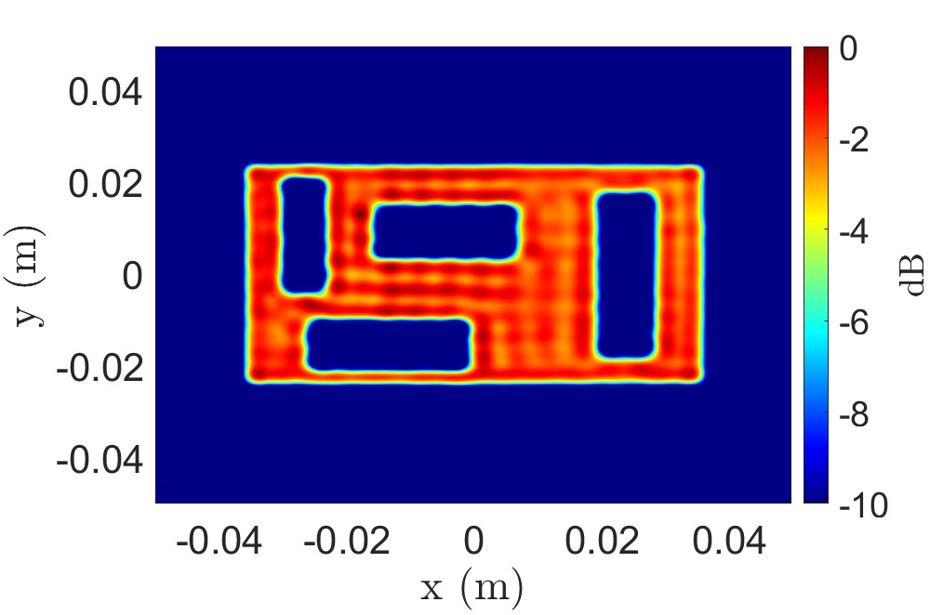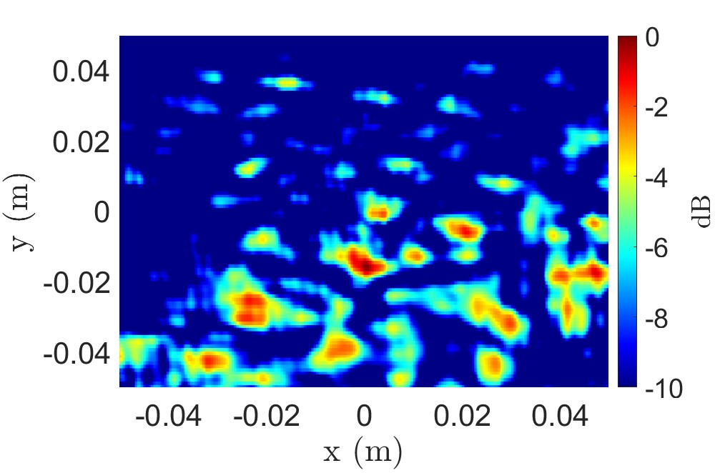

(a) (b)

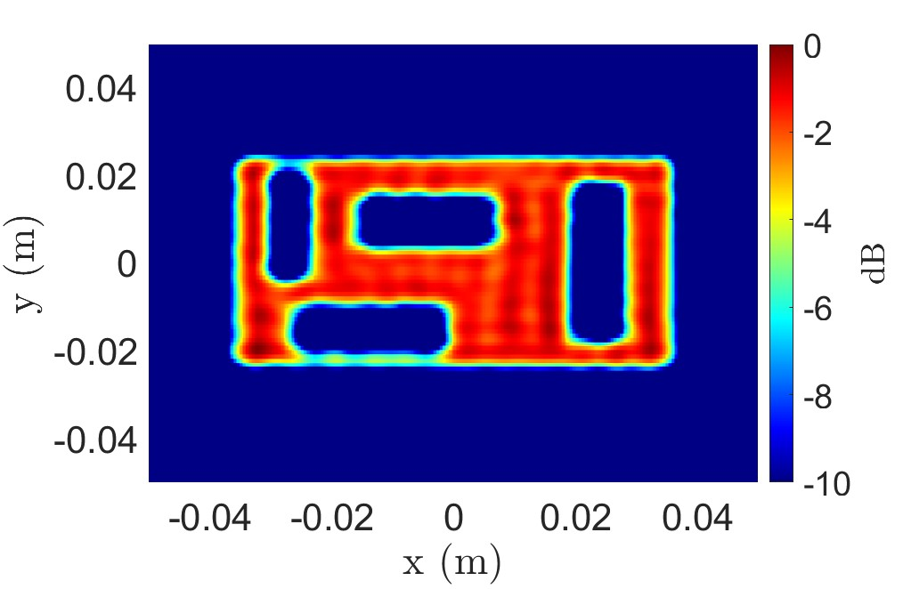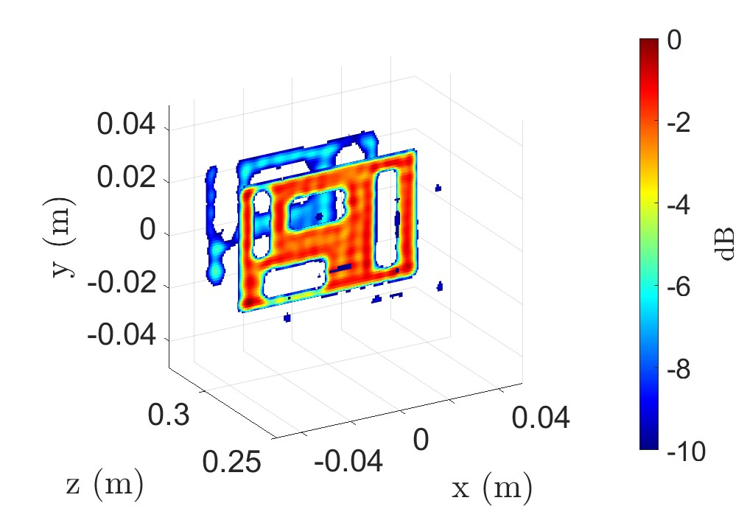

(c) (d)

Figure 8: Imaging results for the scenario in Fig. 7 using the (a) BPA (1324.8 s), (b) RMA without multi-planar multistatic compensation (1.1 s), (c) proposed algorithm at the *z* = 300 mm plane (1.1 s), and (d) the 3-D reconstructed image using the proposed technique (4.8 s).

Considering the more broadly applicable 2-D scanning case, a 2-D multi-planar multistatic scenario was simulated with a solid target located at *z* = 300 mm, as shown in Fig. 7. The target is a rectangular strip with cutouts of various sizes and the irregular sampling geometry is generated as a 2-D semi-smooth random curve occupying *x*′ ∈ [−12*.*5*,*12*.*5] cm, *y*′ ∈ [−12*.*5*,*12*.*5] cm, and *zℓ* ∈ [−2*.*5*,*2*.*5] cm with 102956 sampling locations. Because the target was located on a single *z*-plane parallel to the planar projection after our compensation technique, a 2-D *x*-*y* image was recovered at *z* = 300 mm. Again, while BPA yields a robust reconstruction, the computation time is excessive for most applications, requiring 1324.8 s on a desktop machine. On the other hand, the proposed algorithm outperforms the RMA significantly in terms of image quality, nearly matching that of the BPA with only slight artifacting, while demonstrating superior efficiency to the BPA computing a high-resolution 2-D image in only 1.1 s. Similarly, 3-D images can be reconstructed using these methods. The 3-D reconstructed image using the proposed algorithm is shown in Fig. 8d, requiring 4.8 s to compute, while the RMA and BPA are computed in 4.8 s and 339159.2 s, respectively.

Comparing the results from Figs. 6 and 8, aberrations appear to be more pronounced along the *z*-dimension or depth. This phenomenon is expected, given the analysis in Section II-B, where  and the size of the target in the *z*-direction are assumed to be small. Hence, for targets of significant size in the *z*-direction, such as the target in Fig. 6c, the proposed compensation suffers from slight artifactting compared to BPA. However, for many applications, the considerable time savings achieved using our technique is a necessary trade-off compared with the prohibitively slow BPA.

# B. EMPIRICAL IRREGULAR GEOMETRY SAR IMAGING RESULTS

The multiplanar multistatic imaging technique and system prototype were validated experimentally by capturing the SAR data of various target scenes, as shown in Fig 9. The reconstructed images obtained using each method were compared and discussed.

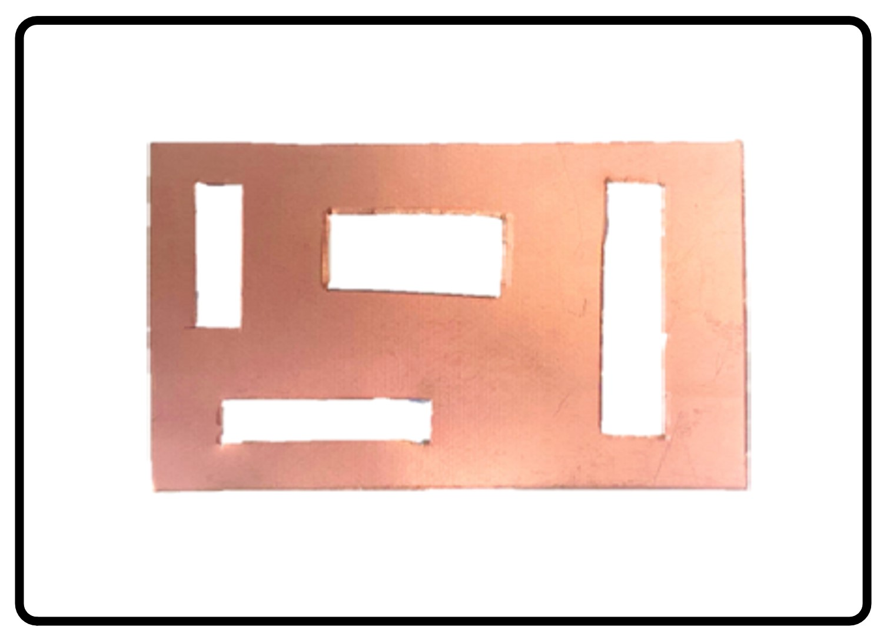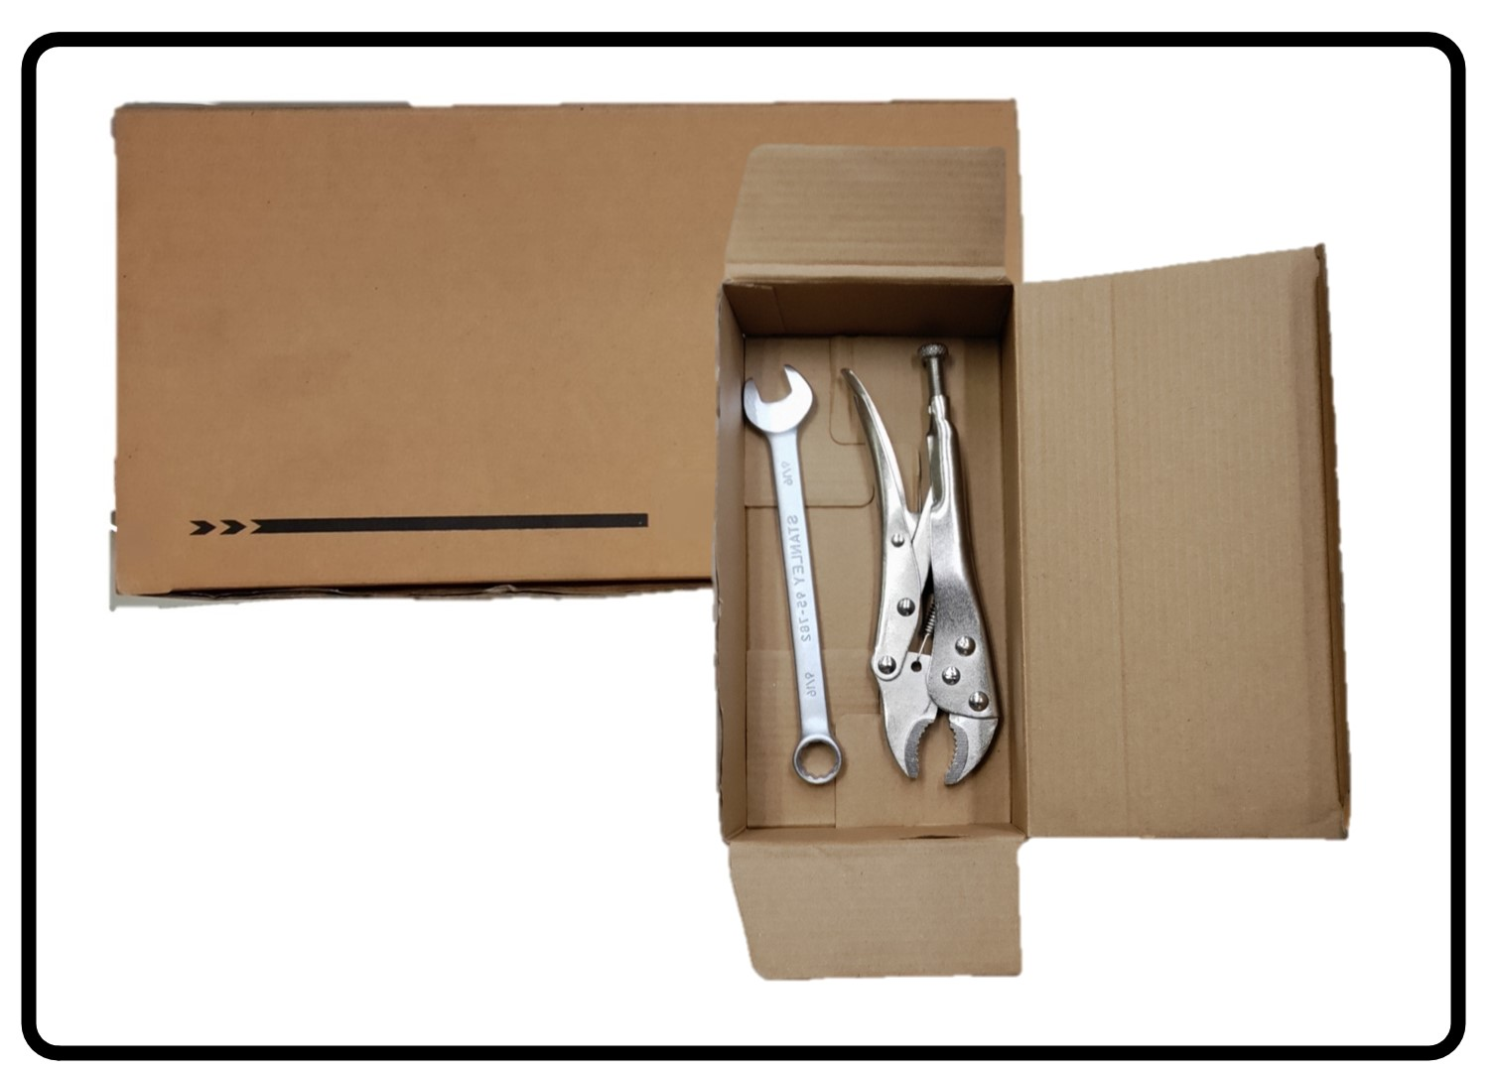

(a) (b)

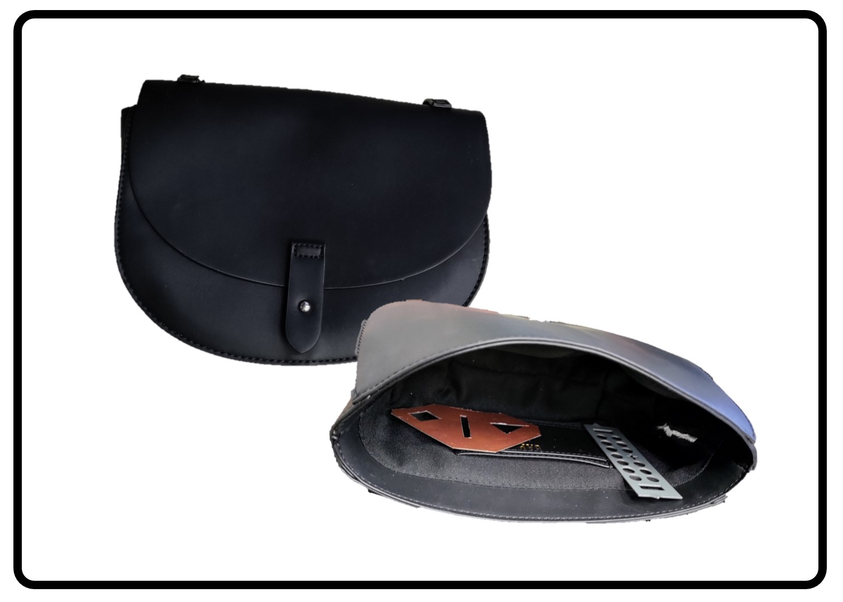

(c)

Figure 9: Various experimental targets: (a) copper clad laminate test target, (b) tools hidden inside box, and (c) purse containing metal cutouts.

The test target with several horizontal and vertical rectangular cutouts made from copper-clad laminate (Fig. 9a) was illuminated by the *x*-*y* scanner at the planes *z* ∈ [275*,*324] mm with a separation of 1 mm. Hence, data are collected throughout the same region discussed previously such that *x*′ ∈ [−12*.*5*,*12*.*5] cm, *y*′ ∈ [−12*.*5*,*12*.*5] cm, and *zℓ* ∈ [−2*.*5*,*2*.*5] cm with 102762 sampling locations. After the data were collected, 50 planar scans were subsampled using similar random 2-D curves as shown in Fig. 7, to emulate the multi-planar irregular sampling scenario. The imaging results and corresponding computation times for each reconstruction algorithm are shown in Fig. 10. Our proposed multiplanar multistatic imaging technique demonstrates robustness in projecting the irregular scanning geometry to a planar scenario for more efficient image recovery, as the cutout is recovered cleanly without significant artifactting, as shown in Fig. 10c. In contrast, the image recovered using BPA requires nearly 30 min to compute, and although the RMA is computed efficiently, the RMA without multiplanar compensation cannot resolve the target scene, as shown in Fig. 10b. Furthermore, when the target location is unknown in the *z*-direction, 3-D imaging offers an improved solution with a higher computational cost.

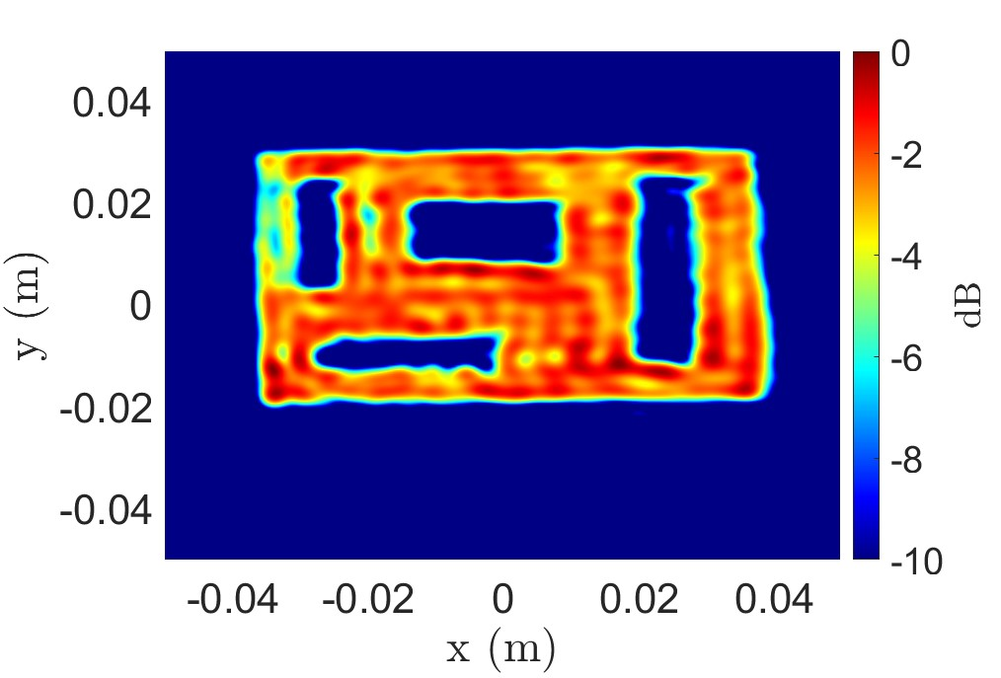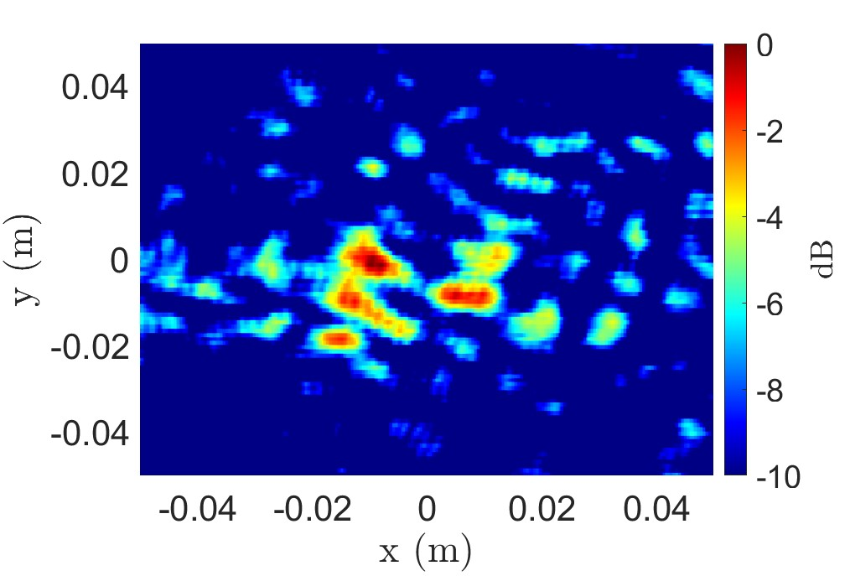

(a) (b)

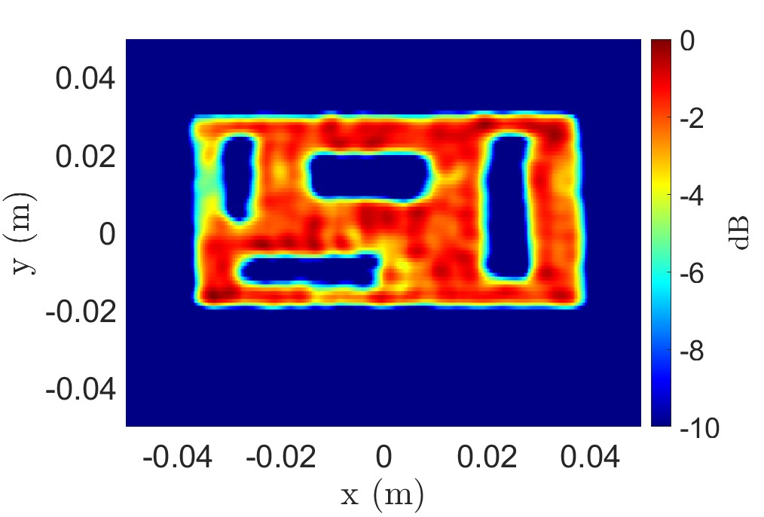

(c)

Figure 10: Imaging results for the copper test target using the (a) BPA (1324.8 s), (b) RMA without multi-planar multistatic compensation (1.1 s), and (c) proposed algorithm (1.1 s).

The second target screened by the prototype to demonstrate a hidden target scenario consisted of two wrenches (a combination wrench and a vise grip) hidden inside a cardboard box, as shown in Fig. 9b. SAR scans of the target were performed with the target at *z*-planes *z* ∈ [275*,*324] mm, with a separation of 1 mm. To accommodate a larger target size, the aperture is increased to *x*′ ∈ [−25*,*25] cm, *y*′ ∈ [−25*,*25] cm, and *zℓ* ∈ [−2*.*5*,*2*.*5] cm with 102545 sampling locations. Similarly, the *x*-*y*-*z* data were sampled to emulate the multiplanar multistatic scenario using a semi-smooth random curve, as shown in Fig. 7. The 2-D and 3-D implementations of the BPA and proposed algorithm are applied to nonuniform data under irregular scanning geometry, and the recovered images are shown in Figs. 11a – 11d. Both wrenches are visible in the reconstructed images; however, while the 2-D image from the BPA and the proposed algorithm provide high-fidelity reconstructions of the hidden tools, the 2-D *z*-plane must be carefully selected to obtain such images. The presence and location of targets are generally unknown for concealed item detection problems. Hence, 3-D imaging is preferable for such scenarios and is primarily constrained by computational expense. Our proposed algorithm offers an elegant compromise between the efficiency of RMA and the image quality of BPA. In Fig. 11d, the 3-D image is computed by the proposed algorithm with an image quality comparable to that of BPA, with a significantly reduced computational cost.

A third experiment was conducted with several metal cutouts concealed in a purse to emulate a scenario wherein a suspicious personal item was quickly screened with an irregular scanning geometry, such as freehand SAR or drone imaging. Fig 9c shows the purse and two hidden items: a triangularly shaped metal plate with different cutout shapes and a rectangular metal plate with circular holes. The target was scanned by the multi-planar multistatic prototype discussed in Section IV, and the data were employed to emulate an irregular sampling scenario. Scans are performed with the target at the *z*-planes *z* ∈ [275*,*324] mm with a separation of 1 mm and an aperture is synthesized within *x*′ ∈ [−25*,*25] cm, *y*′ ∈ [−25*,*25] cm, and *zℓ* ∈ [−2*.*5*,*2*.*5] cm with 102821 sampling locations. The reconstructed images and corresponding computation times are shown in Figs. 11e – 11h. Both metal cutouts were resolved using our algorithm, with an image quality comparable to that of BPA. Again, assuming that the contents of the purse are generally unknown, computing the 3-D image is preferable for concealed item detection. To efficiently recover a 3-D image with irregularly sampled data, Existing inversion techniques require excessive computation time and memory capacity, as shown in Figs. 11e and 11f. However, our proposed algorithm (Figs. 11g and 11h) offers an efficient solution that does not compromise image quality.

These experiments demonstrate the advantages of the proposed algorithm and the limitations of the RMA and BPA. A comparison of the computation times required for each algorithm is presented in Table 1. Applying the RMA directly to the multiplanar data, as shown in Figs. 6c, 8b, and 10b, yields significant aberrations at the point of failed reconstruction. For this reason, RMA images are not shown in the other examples. When the target is known to be 2-D and located at a single known *z*-plane, the 2-D BPA implementation can be computed somewhat efficiently in certain instances by employing a graphics processing unit (GPU) and parallelizing the computation [7], [10]–[13]. However, particularly for mobile applications, access to high-capacity GPUs is rare or size-prohibitive, and such acceleration is infeasible. Moreover, as BPA is scaled up to three dimensions, the time and space complexities increase exponentially, requiring excessive computational power and memory. In many emerging applications, efficient 3-D image computation on low-power devices is preferable, if not mandatory, as the precise location of the target is generally unknown. However, efficient algorithms, such as RMA, require monostatic, planar assumptions that are unachievable by these applications. To enable such technologies, our proposed multiplanar multistatic imaging algorithm efficiently compensates for the irregular scanning geometry by carefully handling the phase of each sample. This enables image reconstruction under dynamic conditions with computational complexity identical to that of RMA and image quality comparable to that of BPA.

Metal Cutout Hidden Tools Purse

|  |  |  |  |
| --- | --- | --- | --- |
| 2-D BPA | 1324.8 | 5299.4 | 5299.4 |
| 3-D BPA | 339159.2 | 1356636.9 | 1356636.9 |
| 2-D RMA | 1.1 | 4.3 | 4.3 |
| 3-D RMA | 4.8 | 10.7 | 10.7 |
| 2-D Proposed | 1.1 | 4.3 | 4.3 |
| 3-D Proposed | 4.8 | 10.7 | 10.7 |

Table 1: Computation time, in seconds, required by the various algorithms for each experiment.

## VI. CONCLUSION

In this article, we present a novel approach for high-resolution, efficient 3-D near-field SAR imaging for irregular scanning geometries. We propose a multiplanar multistatic framework applicable to a diverse set of applications, including freehand imaging, UAV SAR, and automotive imaging. A novel algorithm is proposed to efficiently compensate for irregularly sampled multiplanar multistatic data to equivalent planar monostatic mmWave radar data. Our technique extends the traditional RMA by presenting an algorithm for efficiently aligning multiplanar multistatic data to a virtual planar monostatic scenario. By projecting the data onto a virtual planar monostatic equivalent array, this method extends the RMA to account for both irregular scanning and MIMOSAR effects, resulting in high-fidelity focusing. The proposed algorithm is valid for common radar signalling techniques in 5G, IoT, smartphones, and automotive applications. The simulation results demonstrate the robustness of our approach in the presence of significant deviation among the samples along the *z*-direction. Furthermore, we empirically validated the proposed algorithm by using a custom prototype to capture multiplanar multistatic data for several concealed and obscured scenarios. In both simulation and experimental studies, our algorithm achieves efficient image reconstruction by matching the focusing quality of existing techniques while reducing computational complexity by a considerable margin.

.

|  |
| --- |
| (a) (b) (c) (d)  (e) (f) (g) (h)  Figure 11: Imaging results for the hidden tools target, as shown in Fig. 9b, using the (a) 2-D BPA (5299.4 s), (b) 3-D BPA (1356636.9 s), (c) 2-D proposed algorithm (4.3 s), and (d) 3-D proposed algorithm (10.7 s). Imaging results for the concealed items in a purse, as shown in Fig. 9c, using the (e) 2-D BPA (5299.4 s), (f) 3-D BPA (1356636.9 s), (g) 2-D proposed algorithm |

(4.3 s), and (h) 3-D proposed algorithm (10.7 s).

### APPENDIX A MULTIVARIATE TAYLOR SERIES EXPANSION

Consider an infinitely differentiable real-valued function and an open neighborhood around (*u,v,w*) = (*u*0*,v*0*,w*0). Let **x** = [*u v w*]*T* and **x**0 = [*u*0 *v*0 *w*0]*T*. Hence, the multivariate Taylor series expansion of *f*(**x**) in the neighborhood of **x**0 can be written as:

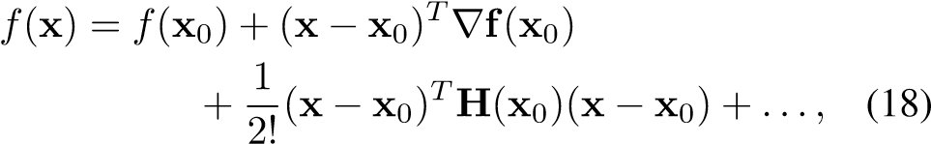

where ∇**f** is the vector of first derivatives

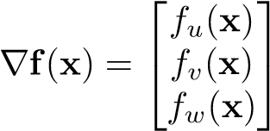 *,* (19)

and **H**(**x**) is the Hessian matrix of the second derivatives as

**H**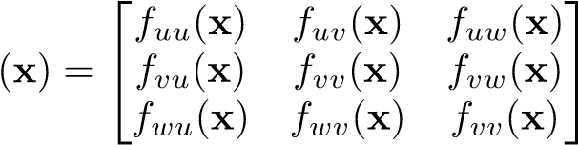 *.* (20)

# A. TAYLOR SERIES EXPANSION OF ROUND-TRIP DISTANCE FOR IRREGULAR SCANNING GEOMETRIES

The round-trip distance between the *ℓ*-th Tx/Rx pair, whose transmitter and receiver elements are located at (*xT,yT,zℓ*) and (*xR,yR,zℓ*), respectively, and the scatterer located at (*x,y,z*) is expressed in (2). Substituting (3) and (4) into (2), *RℓRT* can be expressed as a function of the distances between the Tx and Rx elements along the *x*- and *y*-directions, *dxℓ* and , respectively, and displacement along the *z*-direction, *dzℓ*:

*RℓRT*(*dxℓ ,dyℓ,dzℓ*)

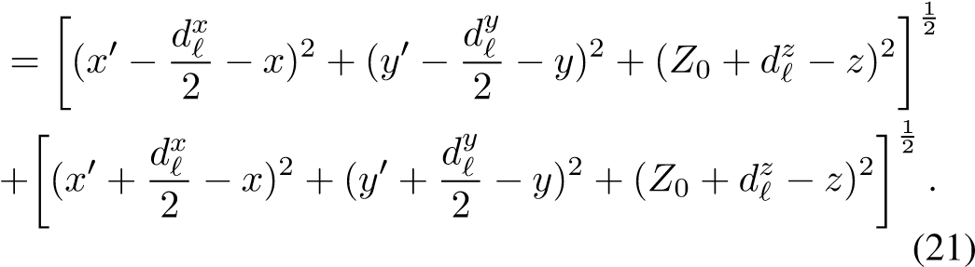

The first derivatives of (21), evaluated at *dxℓ* = *dyℓ* = *dzℓ* = 0, are

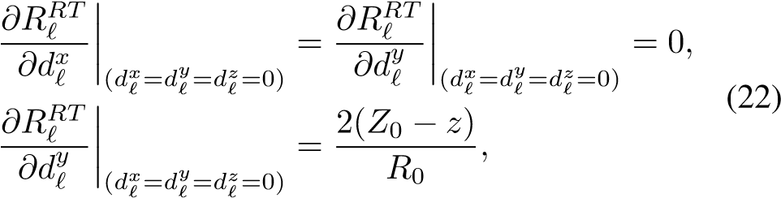

where *R*0 is the distance between the virtual monostatic element located at (*x*′*,y*′*,Z*0) and the point scatterer at (*x,y,z*), as expressed in (6).

The second derivative of (21), evaluated at the point of interest, can be derived asfollows:

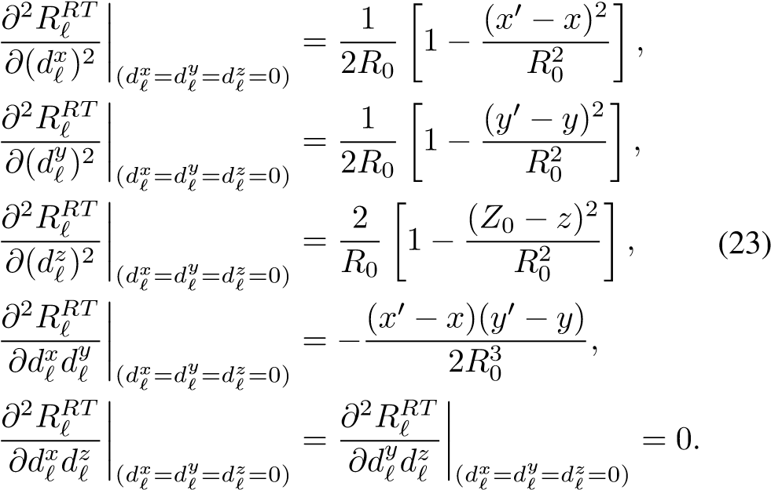

Substituting (22) and (23) into (18), the quadratic approximation of *Rℓ* can be expressed as

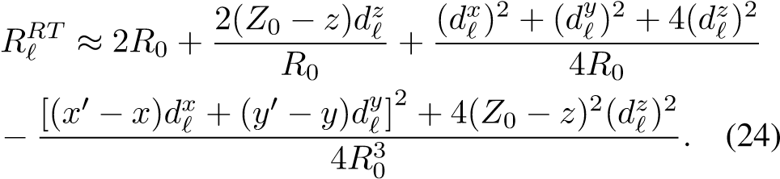

## References

1. J. W. Smith, S. Thiagarajan, R. Willis, Y. Makris, and M. Torlak, “Improved static hand gesture classification on deep convolutional neural networks using novel sterile training technique,” *IEEE Access*, vol. 9, pp. 10893–10902, Jan. 2021.
2. D. M. Sheen, T. E. Hall, D. L. McMakin, A. M. Jones, and J. R. Tedeschi, “Three-dimensional radar imaging techniques and systems for near-field applications,” in *Proc. SPIE 9829 Radar Sensor Techn. XX*, Baltimore, MD, USA, May 2016, pp. 230–241.
3. M. E. Yanik and M. Torlak, “Near-field 2-D SAR imaging by millimeter-wave radar for concealed item detection,” in *Proc. IEEE RWS*, Orlando, FL, USA, Jan. 2019, pp. 1–4.
4. L. Chao, M. N. Afsar, and K. A. Korolev, “Millimeter wave dielectric spectroscopy and breast cancer imaging,” in *Proc. IEEE EuMIC*, Amsterdam, Netherlands, Oct. 2012, pp. 572–575.
5. Y. Gao and R. Zoughi, “Millimeter wave reflectometry and imaging for noninvasive diagnosis of skin burn injuries,” *IEEE Trans. Instrum. Meas.*, vol. 66, no. 1, pp. 77–84, Nov. 2016.
6. O. Li, J. He, K. Zeng, *et al.*, “Integrated sensing and communication in 6G a prototype of high resolution THz sensing on portable device,” in *Proc. IEEE EuCNC/6G*, Porto, Portugal, Jun. 2021, pp. 544–549.
7. G. Álvarez-Narciandi, J. Laviada, and F. Las-Heras, “Towards turning smartphones into mmWave scanners,” *IEEE Access*, vol. 9, pp. 45147–45154, Mar. 2021.
8. K. Basrawi and R. Dill, “Reverse engineering the Soli radar API for military applications,” in *Proc. IEEE RadarConf21*, Jun. 2021, pp. 1–8.
9. J. W. Smith, O. Furxhi, and M. Torlak, “An FCNNbased super-resolution mmWave radar framework for contactless musical instrument interface,” *IEEE Trans. Multimedia*, pp. 1–1, May 2021.
10. G. Álvarez-Narciandi, M. López-Portugués, F. LasHeras, and J. Laviada, “Freehand, agile, and highresolution imaging with compact mm-Wave radar,” *IEEE Access*, vol. 7, pp. 95516–95526, Jul. 2019.
11. G. Álvarez-Narciandi, J. Laviada, and F. Las-Heras, “Freehand mm-Wave imaging with a compact MIMO radar,” *IEEE Trans. Antennas Propag.*, vol. 69, no. 2, pp. 1224–1229, Feb. 2021.
12. G. Álvarez-Narciandi, J. Laviada, Y. Álvarez-López, *et al.*, “Freehand system for antenna diagnosis based on amplitude-only data,” *IEEE Trans. Antennas Propag.*, vol. 69, no. 8, pp. 4988–4998, Feb. 2021.
13. H. F. Álvarez, G. ÁLvarez-Narciandi, F. Las-Heras, and J. Laviada, “System based on compact mmWave radar and natural body movement for assisting visually impaired people,” *IEEE Access*, vol. 9, pp. 125042– 125051, Sep. 2021.
14. H. Wymeersch, G. Seco-Granados, G. Destino, D. Dardari, and F. Tufvesson, “5G mmWave positioning for vehicular networks,” *IEEE Wireless Commun.*, vol. 24, no. 6, pp. 80–86, Dec. 2017.
15. Z. Hajiakhondi-Meybodi, M. Salimibeni, K. N. Plataniotis, and A. Mohammadi, “Bluetooth low energybased angle of arrival estimation via switch antenna array for indoor localization,” in *Proc. IEEE FUSION*, Rustenburg, South Africa, Jul. 2020, pp. 1–6.
16. J. W. Smith, M. E. Yanik, and M. Torlak, “Nearfield MIMO-ISAR millimeter-wave imaging,” in *Proc. IEEE RadarConf*, Florance, Italy, Sep. 2020, pp. 1–6.
17. M. E. Yanik and M. Torlak, “Near-field MIMO-SAR millimeter-wave imaging with sparsely sampled aperture data,” *IEEE Access*, vol. 7, pp. 31801–31819, Mar. 2019.
18. M. E. Yanik, D. Wang, and M. Torlak, “3-D MIMOSAR imaging using multi-chip cascaded millimeterwave sensors,” in *Proc. IEEE GlobalSIP*, Ottawa, ON, Canada, Nov. 2019, pp. 1–5.
19. J. M. Lopez-Sanchez and J. Fortuny-Guasch, “3D radar imaging using range migration techniques,” *IEEE Trans. Antennas Propag.*, vol. 48, no. 5, pp. 728– 737, May 2000.
20. M. E. Yanik, D. Wang, and M. Torlak, “Development and demonstration of MIMO-SAR mmWave imaging testbeds,” *IEEE Access*, vol. 8, pp. 126019–126038, Jul. 2020.
21. C. F. Baumgartner, K. Kamnitsas, J. Matthew, *et al.*, “SonoNet: Real-time detection and localisation of fetal standard scan planes in freehand ultrasound,” *IEEE Trans. Medical Imaging*, vol. 36, no. 11, pp. 2204– 2215, Jul. 2017.
22. J. Blackall, G. Penney, A. King, and D. Hawkes, “Alignment of sparse freehand 3-D ultrasound with preoperative images of the liver using models of respiratory motion and deformation,” *IEEE Trans. Medical Imaging*, vol. 24, no. 11, pp. 1405–1416, Oct. 2005.
23. M. W. Gilbertson and B. W. Anthony, “Force and position control system for freehand ultrasound,” *IEEE Trans. Robotics*, vol. 31, no. 4, pp. 835–849, Jun. 2015.
24. J. W. Smith and M. Torlak, “Terhertz imaging toolbox with interactive user interface,” *unpublished*, 2022.
25. X. Zeng, Y. Ma, Z. Li, J. Wu, and J. Yang, “A near-field fast time-frequency joint 3-D imaging algorithm based on aperture linearization,” in *Proc. IEEE IGARSS*, Brussels, Belgium, Oct. 2021, pp. 5163– 5166.
26. M. Garcia-Fernandez, Y. Alvarez-Lopez, and F. L. Heras, “3D-SAR processing of UAV-mounted GPR measurements: Dealing with non-uniform sampling,” in *Proc. IEEE EuCAP*, Copenhagen, Denmark, Aug. 2020, pp. 1–5.
27. B. Wu, G. Álvarez-Narciandi, and J. Laviada, “Multilayered circular dielectric structure SAR imaging using time-reversal compressed sensing algorithms based on nonuniform measurement,” *IEEE Antennas Wireless Propag. Lett.*, vol. 19, no. 9, pp. 1491–1495, Jul. 2020.
28. T. Kan, G. Xin, L. Xiaowei, and L. Zhongshan, “Implementation of real-time automotive SAR imaging,” in *Proc. IEEE SAM*, Hangzhou, China, Jun. 2020, pp. 1–4.
29. D. M. Sheen, D. L. McMakin, and T. E. Hall,

“Three-dimensional millimeter-wave imaging for concealed weapon detection,” *IEEE Trans. Microw. Theory Techn.*, vol. 49, no. 9, pp. 1581–1592, Sep. 2001.

1. J. Gao, Y. Qin, B. Deng, H. Wang, and X. Li, “Novel efficient 3D short-range imaging algorithms for a scanning 1D-MIMO array,” *IEEE Trans. Image Process.*, vol. 27, no. 7, pp. 3631–3643, Apr. 2018.
2. B. Fan, J. Gao, H. Li, Z. Jiang, and Y. He, “Nearfield 3D SAR imaging using a scanning linear MIMO array with arbitrary topologies,” *IEEE Access*, vol. 8, pp. 6782–6791, Dec. 2019.
3. J. Gao, B. Deng, Y. Qin, H. Wang, and X. Li, “Efficient terahertz wide-angle NUFFT-based inverse synthetic aperture imaging considering spherical wavefront,” *Sensors*, vol. 16, no. 12, p. 2120, Dec. 2016.
4. R. K. Amineh, N. K. Nikolova, and M. Ravan, *RealTime Three-Dimensional Imaging of Dielectric Bodies Using Microwave/Millimeter Wave Holography*. John Wiley & Sons, 2019.
5. J. H. G. Ender and J. Klare, “System architectures and algorithms for radar imaging by MIMO-SAR,” in *Proc. IEEE RadarConf*, Pasadena, CA, USA, May 2009, pp. 1–6.
6. F. Roos, J. Bechter, C. Knill, B. Schweizer, and C. Waldschmidt, “Radar sensors for autonomous driving: Modulation schemes and interference mitigation,”

*IEEE Microw. Mag.*, vol. 20, no. 9, pp. 58–72, Aug. 2019.

1. J. Wang, P. Aubry, and A. Yarovoy, “3-D shortrange imaging with irregular MIMO arrays using NUFFT-based range migration algorithm,” *IEEE Trans. Geosci. Remote Sens.*, vol. 58, no. 7, pp. 4730– 4742, Jan. 2020.
2. L. Greengard and J.-Y. Lee, “Accelerating the nonuniform fast Fourier transform,” *SIAM Rev.*, vol. 46, no. 3, pp. 443–454, Aug. 2006.
3. D. Sheen, D. McMakin, and T. Hall, “Near-field threedimensional radar imaging techniques and applications,” *Appl. Opt.*, vol. 49, no. 19, E83–E93, Jun. 2010.
4. T. Zhang and X.-G. Xia, “OFDM synthetic aperture radar imaging with sufficient cyclic prefix,” *IEEE Trans. Geosci. Remote Sens.*, vol. 53, no. 1, pp. 394– 404, Jan. 2015.

JOSIAH W. SMITH (S’18) was born in Denver, CO, USA in 1997. He received the B.S. degree (*summa cum laude*) in electrical engineering from The University of Texas at Dallas in 2019, where he is currently pursuing a Ph.D. degree in electrical engineering specializing in communications engineering. He was awarded the Texas Instruments Analog Excellence Graduate Fellowship in August 2019 and the Louis Beecherl, Jr. Graduate Research Fellowship in August 2021. During

the summer of 2020, he developed real-time human-computer interaction algorithms for mmWave radar with imec-USA. In the summer of 2021, he developed advanced deep learning and data-driven algorithms for user experience enhancement at Apple in the Display Technologies group. His current research interests include hybrid-learning algorithms, new regime radar imaging algorithm development, ultra-wideband radar imaging algorithms, terahertz radar, radar perception, computer vision, deep learning, millimeter-wave sensing, and phased array signal processing.

MURAT TORLAK (SM’04) received the M.S. and Ph.D. degrees in electrical engineering from The University of Texas at Austin, in 1995 and 1999, respectively. Since August 1999, he has been with the Department of Electrical and Computer Engineering, The University of Texas, where he has been promoted to the rank of a Full Professor. He is serving as a Rotating Program Director at the U.S. National Science Foundation (NSF).

His current research interests include experimental

verification of wireless networking systems, cognitive radios, millimeterwave automotive radars, millimeter-wave imaging systems, and interference mitigation in radio telescopes. He was the General Chair of Symposium on Millimeter Wave Imaging and Communications in the 2013 IEEE GlobalSIP Conference. He has served as an Associate Editor for the IEEE Transactions on Wireless Communications, from 2008 to 2013. He is a Guest co-Editor of IEEE JSTSP Special Issue on Recent Advances in Automotive Radar Signal Processing, 2021.

Dear Dr. Gerardo Di Martino,

Please find attached our manuscript titled “Efficient 3-D Near-Field MIMO-SAR Imaging for Irregular Scanning Geometries,” which we would like to submit for publication as an original research article in your journal, *IEEE Access*. Our main contribution is an efficient algorithm for high-resolution near-field MIMO-SAR under irregular SAR geometries. Our analysis employs a novel approach to irregular SAR geometries in the near-field to project irregular multistatic synthetic arrays to virtual planar monostatic arrays. For many applications, e.g., drone imaging, freehand imaging, automotive SAR, etc., computational tractable algorithms for required for SAR imaging on irregular scanning geometries. Our novel algorithm offers an efficient solution to near-field irregular MIMO-SAR. This work has not been submitted elsewhere. Our recent submission with ID Access-2021-38447, was not recommended for publication and we have taken the necessary steps to rectify issues in our paper and comprehensively address the reviewers’ concerns. We have attached a document containing our responses to the reviewers’ comments on our previous submission with noted changes to our manuscript, an updated manuscript with individual changes highlighted, and a clean copy of our final manuscript.

We are looking forward to hearing from you.

Sincerely,

J. W. Smith and M. Torlak

**Original Manuscript ID:** Access-2021-38447

**Original Article Title:** “Efficient 3-D Near-Field MIMO-SAR Imaging for Irregular Scanning Geometries”

**To:** IEEE Access Editor

**Re:** Response to reviewers

Dear Dr. Gerardo Di Martino,

Thank you for allowing us to resubmit our manuscript with an opportunity to address the reviewers’ comments.

We have uploaded (a) our point-by-point responses to the comments (below) (response to reviewers), (b) an updated manuscript with yellow highlighting indicating changes, and (c) a clean updated manuscript without highlights (PDF main document).

Best regards,

J. W. Smith and M. Torlak

**Reviewer #1, Concern #1:** The authors said the proposed method ‘enables such mobile and internet of things (IoT) applications through efficient image reconstruction.’ However, 5G and IoT signals are usually modulated into an orthogonal frequency division multiplexing (OFDM) form, whereas the experiments reveal that LFM signals are employed in this study. Can you explain this?

**Author response:** The authors are grateful for the comments and suggestions of Reviewer #1. Owing to the diversity of modulation schemes, the signal model presented in Section II-C provides a generalized model to accommodate both OFDM and LFM radars, both of which are found in smartphones and IoT hardware. The reviewer is correct that it is common practice for 5G and IoT signaling to employ orthogonal frequency division multiplexing (OFDM) as opposed to linear frequency modulation (LFM) or frequency-modulated continuous wave (FMCW), which is common in automotive radar. Furthermore, the proposed algorithm discussed in Sections II and III is applicable to both OFDM and LFM signaling schemes, as clarified in the updated version of the manuscript. In addition, we have included further references for the reader detailing OFDM radar for ranging and synthetic aperture (SAR) imaging. On the other hand, FMCW (LFM) modulation has been employed previously for smartphone applications to achieve radar sensing in Google Pixel 4 with Google Soli radar, and is commonly used for sensing exclusively in IoT applications. Prior work on smartphone SAR and similar applications employed a purely LFM, stepped frequency signal model [10]–[13]. Therefore, the signal model in Section II is generalized for any UWB modulation scheme, and the proposed algorithm is applicable to both LFM and OFDM modulation schemes.

We appreciate the reviewer’s suggestion and have made changes to provide a clear explanation for the audience.

**Author action:** We updated the manuscript by the following actions:

1. In Section II-C, we added the following sentence to clarify the validity of the generalized signal model for common UWB modulation schemes.

“The frequency-domain model of the received signal (9) is valid for any UWB radar signaling scheme, including frequency-modulated continuous-wave (FMCW), phase modulated continuous wave (PMCW), or orthogonal frequency-division multiplexing (OFDM), commonly employed in 5G and IoT applications [35]. Furthermore, prior research on freehand imaging and similar IoT applications has employed a purely stepped-frequency FMCW signal model [10]-[13]. Similarly, Google Pixel 4 utilizes a Google Soli 60 GHz mmWave FMCW radar for sensing [8].”

1. In Section IV, we clarify the choice of an FMCW radar and the efficacy of the proposed algorithm for both OFDM and FMCW radar signaling by adding the following.

“While 5G and IoT applications commonly employ an OFDM modulation scheme, the TI radar employed for the following experiments is limited to FMCW signaling. In contrast, FMCW radar has been utilized for smartphone applications, notably Google Pixel 4, which is equipped with Google Soli FMCW radar [8]. The proposed range migration-based algorithm is applicable to both OFDM and FMCW radars; hence, the results discussed in the following section are relevant for a wide array of 5G, IoT, smartphone, and automotive applications [39].”



**Reviewer #1, Concern #2:** It seems that the Tx and Rx are fixed on the board and have the same movement state because the TI AWR1443BOOST is used in the experiments. Does this meet the requirements for irregular sampling in a real scene?

**Author response:** We appreciate this comment from the reviewer. The reviewer is correct that the transmit (Tx) and receive (Rx) elements were fixed on the radar board in the experiments. However, the number of elements on the board is small, such that the radar is suitable for a smartphone or an IoT application. However, the challenge is to synthetically create a uniform aperture geometry. Existing techniques for image reconstruction with noncooperative near-field scanning geometries are computationally burdensome and infeasible for mobile applications. The irregular scanning geometry investigated in this study, referred to as multi-planar multistatic, is an extension of the common planar MIMO-SAR scanning mode. In planar MIMO-SAR, a multistatic radar platform is scanned across a planar aperture, which implies that the Tx and Rx elements are fixed to the board and spatially translated as the radar is scanned across the planar track. The algorithm proposed in our manuscript offers an efficient solution to the MIMO-SAR case, such that the planar assumption does not hold. For applications such as freehand smartphone imaging or automotive SAR, the MIMO radar is scanned across space, but the planar array assumption is invalid. For the multi-planar MIMO-SAR scanning mode described in Section II-A and shown in Fig. 1, Tx and Rx are fixed on the radar and the entire radar platform is moved throughout space in an irregular scanning pattern. Hence, TI AWR1443BOOST used in the experiments met the irregular sampling conditions investigated in this study.

To provide further clarity, we have added additional details to Section II-A, explaining the multi-planar MIMO-SAR operation and its potential applications.

**Author action:** We have updated the manuscript by adding the following paragraph to Section II-A:

“Compared to planar MIMO-SAR, which requires a multistatic MIMO array to be scanned across a planar track [17], [20], [31], multi-planar MIMO-SAR allows the multistatic array to be scanned across 3-D space. For freehand imaging or automotive SAR, a MIMO array is fixed to a smartphone or vehicle, respectively, and is moved throughout space, generating a multi-planar MIMO-SAR irregular aperture. As shown in Fig. 1, because the multistatic array is scanned in an irregular pattern spanning multiple *z*-planes, the locations of the transmit (Tx) and receive (Rx) elements are spatially translated by the movement of the MIMO array. The analyses in the subsequent sections present an efficient solution to irregular MIMO-SAR imaging, such that the position of the radar is known throughout the scan and the planar array assumption does not hold. This scenario is common for many of the aforementioned applications, which necessitates both irregular scanning geometries and efficient image recovery.”



**Reviewer #1, Concern #3:** The sampling rates, that is, the pulse repetition frequency (PRF) and sampling rate in the base band, should be analyzed to avoid undersampling.

**Author response:** We agree with the reviewer’s comment and have included a more detailed analysis of spatial sampling rates to avoid undersampling. The spatial and sampling, dictated by the pulse petition frequency (PRF) and baseband sampling rate, are both relevant factors in system design and implementation and have been explored more thoroughly in the updated manuscript.

**Author action:** We have updated the manuscript by making the highlighted change to the following excerpt from Section III:

“Sampling considerations for image reconstruction remain identical to those in analyses elsewhere [17], [29] after the multi-planar compensation algorithm. The baseband frequency sampling criteria can be determined using the maximum range for a given application. As given in [38], the maximum frequency sampling interval is given by , where is the maximum target range. While spatial sampling criteria are not guaranteed for irregular SAR scanning if the relationship between the capture rate of the radar and the velocity of the radar platform is tuned appropriately during system design, undersampling artifacts are minimal in most cases [10]–[13]. To avoid spatial undersampling, the lower bound of the pulse repetition frequency (PRF) can be computed using PRF, where is the maximum velocity for a certain application. For example, assuming that the maximum velocity of the human hand for a freehand SAR is 1 m/s and a center frequency of 79 GHz, the lower bound of the PRF is approximately 1.06 kHz. It is important to note that the number of captures increases proportionally to the PRF; hence, at high velocities, a large number of samples are captured. The computational performance of traditional techniques that employ BPA degrades substantially when many samples are captured. On the other hand, the signal-to-noise ratio can be improved by increasing the number of samples at the cost of an increased computational burden. Hence, an efficient algorithm for multiplanar MIMO-SAR imaging is required to enable many such technologies.”



**Reviewer #1, Concern #4:** It is a good work to analysis the 3D resolutions in Eq.(17). Why did we not validate these resolutions in the experiments?

**Author response:** This comment, in addition to concern #3 of Reviewer #2, is an excellent suggestion to bolster the robustness of this study. We have revised the manuscript to include an investigation of the spatial resolution and the impact of the extent of sampling irregularity on the imaging resolution. The resolution of the proposed algorithm is compared with that of the ideal planar RMA image reconstruction algorithm with varying degrees of array perturbation.

**Author action:** We updated the manuscript by including a thorough study of the impact of sampling irregularity on image resolution by considering the point spread function (PSF) for several non-cooperative scanning geometries. Each PSF was simulated with a different value for , the maximum distance between the reference plane, , and the samples, as defined in Section II-B. The simulated PSFs were compared with the PSF from an ideal planar scenario using traditional RMA. As the value of increases and the synthetic array becomes increasingly nonplanar, the resolution of the main lobe along the ­­*y*- and *z*-directions degrades marginally, and inferior sidelobe suppression is observed. However, even with significant perturbations in the array geometry, the resolution of the proposed algorithm is quite similar to that of RMA under ideal conditions. Prior work on freehand smartphone imaging system design and implementation assumed deviations of the order of 1 cm [7]. The results are detailed in the updated manuscript in Section V-A, and are presented in Fig. 5. Further details and explanations are provided for Reviewer #2 and Concern #3.



**Reviewer #1, Concern #5:** The RM algorithm appears to have been adopted in the case of 3D non-cooperative SAR imaging. Can you explain the difference between the traditional and proposed RM algorithms?

**Author response:** The authors appreciate this comment from Reviewer #1. The proposed range migration (RM) algorithm is an adapted version of the traditional RM algorithm for 3-D non-cooperative MIMO-SAR in the near field. The proposed algorithm efficiently solves both the multi-planar (irregular) sampling problem and the MIMO-SAR problem by aligning the multiplanar multistatic data to virtual planar monostatic data for efficient image reconstruction. The multiplanar multistatic-to-planar monostatic projection is the main difference between the proposed and conventional RM algorithms. This crucial step compensates for both the sampling irregularities and multistatic MIMO effects simultaneously while significantly reducing dimensionality and computational complexity. The manuscript has been updated to explicitly describe the novelty of the proposed algorithm.

**Author action:** We updated the manuscript by the following actions:

1. In Section I, we clarify the distinction between the traditional RMA and our proposed algorithm by including the following highlighted portion of this paragraph.

“In this article, we propose a novel image reconstruction technique for efficient near-field imaging with irregular scanning geometries, such as those present in freehand imaging, UAV SAR, or automotive scenarios. We examined the system and signal models for UWB MIMO-SAR and developed a multiplanar multistatic approach to mathematically decompose the irregularly sampled synthetic array such that an equivalent virtual planar monostatic array can be constructed. This technique is the first to extend the range migration algorithm (RMA) such that noncooperative SAR scanning and multistatic effects are simultaneously mitigated. The analysis in the subsequent sections provides a novel framework for decomposing irregular SAR scenarios and efficiently projecting irregular MIMO-SAR samples into a virtual planar monostatic equivalent. The proposed algorithm was validated through simulation and experimentation, demonstrating its robustness to arbitrary scanning patterns and low computational complexity. Our solution enables emerging technologies that require non-ideal SAR scanning geometries, MIMO multistatic radar, and efficient image reconstruction.”

1. In Section III, we have added the following details to further address the novelty of this study.

“The key difference between traditional RMA and the proposed algorithm is the alignment of the multi-planar multistatic (MIMO-SAR) data to virtual planar monostatic data. This crucial step compensates for both the sampling irregularities and multistatic MIMO effects simultaneously, while significantly reducing the dimensionality from 6-D to 3-D , and subsequently the computational complexity.”

1. In Section VI, we include the highlighted portion below to provide a thorough discussion of the novel extension of our technique to conventional RMA.

In this article, we present a novel approach for high-resolution, efficient 3-D near-field SAR imaging for irregular scanning geometries. We propose a multiplanar multistatic framework applicable to a diverse set of applications, including freehand imaging, UAV SAR, and automotive imaging. A novel algorithm is proposed to efficiently compensate for irregularly sampled multiplanar multistatic data to equivalent planar monostatic mmWave radar data. Our technique extends the traditional RMA by presenting an algorithm for efficiently aligning multiplanar multistatic data to a virtual planar monostatic scenario. By projecting the data onto a virtual planar monostatic equivalent array, this method extends the RMA to account for both irregular scanning and MIMO-SAR effects, resulting in high-fidelity focusing. The proposed algorithm is valid for common radar signalling techniques in 5G, IoT, smartphones, and automotive applications. The simulation results demonstrate the robustness of our approach in the presence of significant deviation among the samples along the *z*-direction. Furthermore, we empirically validated the proposed algorithm by using a custom prototype to capture multiplanar multistatic data for several concealed and obscured scenarios. In both simulation and experimental studies, our algorithm achieves efficient image reconstruction by matching the focusing quality of existing techniques while reducing computational complexity by a considerable margin.



**Reviewer #2, Concern #1:** The authors should include the number of considered samples used to compute each electromagnetic image.

**Author response:** The authors would like to thank the reviewers for their comments and concerns. We agree with the reviewer’s suggestion and have updated the manuscript to include the number of samples in each electromagnetic (EM) image.

**Author action:** We have updated the manuscript to include the number of samples for both the simulated and empirical EM images in Section V.



**Reviewer #2, Concern #2:** The size of the images of Figures 11b, 11d, 12b and 12d could be increased for a better readability.

**Author response:** The reviewer makes a good pointed out that the clarity and readability of Figs. 11b, 11d, 12b, and 12d can be improved. We have merged Figs. 11 and 12 into a single figure covering both columns and have increased the size of the 3-D figures mentioned by the reviewer.

**Author action:** We updated the manuscript by combining Figs. 11 and 12 into a single figure and increasing the size of the figures, as per the reviewer’s suggestion.



**Reviewer #2, Concern #3:** How far can the samples be from plane Z0 in the z-direction? It seems that if the sampling is smooth, samples can be acquired at a large distance from plane Z0.

**Author response:** The authors appreciate the reviewer’s suggestion and agree that the manuscript can be improved by adding a detailed study into the resolution limitations of the proposed algorithm with increasingly irregular arrays. The authors have modified the manuscript to include an investigation of the impact of the distance between the samples, , and the plane on the image resolution. Section V-A and Fig. 5 provide the results and discussion of the resolution of the proposed algorithm as the array is degraded by perturbations and becomes increasingly nonlinear or non-planar. The proposed algorithm achieves nearly identical main-lobe resolution at the cost of increased sidelobes as the array geometry becomes increasingly non-ideal.

**Author action:** We updated the manuscript by adding a paragraph to Section V-A and a figure detailing a study of the spatial resolution of our algorithm compared to the resolution of planar RMA in an ideal planar scanning scenario. Fig. 5 shows the range and cross-range point spread function (PSF) using the proposed algorithm with various irregular arrays of increasing , the maximum value of , the distance between the samples and the reference plane . The PSF results demonstrate the focusing performance of the proposed algorithm compared to the traditional RMA and the main-lobe beamwidth as increases, or the samples are taken farther from the reference plane. The system designed and implemented in [7] for freehand smartphone imaging assumes deviations of the order of 1 cm, and our algorithm achieves a resolution comparable to that of the ideal planar case with much larger values of . The results in Fig. 5 provide further insights into the efficacy and limitations of the proposed algorithm. Further details and explanations are provided for Reviewer #1 and Concern #4.



**Reviewer #2, Concern #4:** In column 1 of page 4, it seems that “is” is missing after “instantaneous wavenumber”

**Author response:** The authors appreciate the careful reading by the reviewer and concur that this portion of the manuscript must be improved. We implemented the suggested changes in the revised manuscript.

**Author action:** We have updated the manuscript by incorporating the changes suggested by the reviewer in the following sentence:

where is the instantaneous wavenumber and is the Fourier transform of .”



**Reviewer #2, Concern #5:** Can you include a link to the preprint/pre-release of [22]?

**Author response:** The authors will gladly share the preprint copy of the reference requested by the reviewer [22] in the previous manuscript and [24] in the updated manuscript. The preprint document is attached as “Supplemental Material not for Review and not for Publication” in the revised manuscript.

**Author action:** We have included the requested preprint document as “Supplemental Material not for Review and not for Publication” in the new submission.



Efficient 3-D Near-Field SAR Imaging for Irregular Scanning Geometries

In this article, we introduce a novel algorithm for efficient near-field synthetic aperture radar (SAR) imaging of irregular scanning geometries. With the emergence of fifth-generation (5G) millimeter-wave (mmWave) devices, near-field SAR imaging is no longer confined to laboratory environments. Recent advances in positioning technology have attracted significant interest for a diverse set of new applications in mmWave imaging. However, many use cases, such as automotive-mounted SAR imaging, unmanned aerial vehicle (UAV) imaging, and freehand imaging with smartphones, are constrained to irregular scanning geometries. Whereas traditional near-field SAR imaging systems and quick personnel security (QPS) scanners employ highly precise motion controllers to create ideal synthetic arrays, emerging applications, mentioned previously, inherently cannot achieve such ideal positioning. In addition, many Internet of Things (IoT) and 5G applications impose strict size and computational complexity limitations that must be considered for edge mmWave imaging technology. In this study, we propose a novel algorithm to leverage the advantages of non-cooperative SAR scanning patterns, small form-factor multiple-input multiple-output (MIMO) radars, and efficient monostatic planar image reconstruction algorithms. We propose a framework to mathematically decompose arbitrary and irregular sampling geometries and a joint solution to mitigate multistatic array imaging artifacts. The proposed algorithm was validated through simulations and an empirical study of arbitrary scanning scenarios. Our algorithm achieves high-resolution and high-efficiency near-field MIMO-SAR imaging, and is an elegant solution to computationally constrained irregularly sampled imaging problems.

**IEEE Access Questions:**

Q: Please add a brief explanation of the type of manuscript you have chosen. This information will help the Associate Editor and the reviewers during peer review to evaluate your manuscript with the correct article type in mind.

A:

Our manuscript presents a novel approach to multiple-input-multiple-output synthetic aperture radar (MIMO-SAR) in the near-field for irregular scanning geometries. In this study, we examine existing work on similar problems, develop a new model for decomposing irregular SAR sampling, and propose a novel efficient algorithm to recover high-resolution images from dynamic scenarios. Our algorithm was validated in both simulation and empirical studies and compared against existing techniques to yield highly resolved images with low computational complexity.

Q: Please describe how your article fits within the scope of IEEE Access. Note that the scope of IEEE Access covers all (but only) IEEE’s fields of interest.

A:

Our manuscript explores novel areas of interest and recent publications in IEEE Access on synthetic aperture radar (SAR) for freehand imaging, irregular scanning geometries, and near-field imaging algorithms and systems. In our article, we pioneered an efficient algorithm for imaging on emerging near-field imaging modalities, for example, drone imaging, freehand imaging, and automotive SAR. Our proposed algorithm is applicable to many 5G and IoT applications in addition to smartphone and automotive SAR imaging.

Q: Please state the unique contributions and advancements made by your article in the related literature.

A:

Our manuscript advances near-field synthetic aperture radar (SAR) imaging techniques by offering a joint solution to irregular sampling geometries and multistatic effects to improve the computational complexity over previous techniques. We developed a novel framework to understand and decompose many irregular sampling problems such that a compensation algorithm can be applied to project irregular arrays to virtual regular arrays for efficient image computation. Whereas recent works have promoted system-level design of sub-wavelength localization for irregular near-field SAR, our efficient algorithm enables such mobile and Internet of things (IoT) applications through efficient image reconstruction.